Optimized K-medoid Algorithm Based Controller Placement in a Software Defined Network: in case of Ethio-Telecom
By: Musa Ahmed Feki


A Thesis Submitted to the
Department of Computer Science and Engineering
School of Electrical Engineering and Computing
Presented in Partial Fulfilment for the Degree of
Masters of Science in Computer Science and Engineering
Office of Graduate Studies
Adama Science and Technology University

January 2020
Adama, Ethiopia

Optimized K-medoid Algorithm Based Controller Placement in a Software Defined Network: in case of Ethio-Telecom
By: Musa Ahmed Feki
Advisor: Dr.-Ing Frezewd Lemma

A Thesis Submitted to the
Department of Computer Science and Engineering
School of Electrical Engineering and Computing
Presented in Partial Fulfilment for the Degree of
Masters of Science in Computer Science and Engineering
Office of Graduate Studies
Adama Science and Technology University

January 2020
Adama, Ethiopia
Statement of Declaration
I hereby declare that this MSc thesis is my original work and has not been presented as a partial degree requirement for a degree in any other university and that all sources of materials used for the thesis have been fully acknowledged.

Name: Musa Ahmed
Signature: _______________________________________________________________________

This thesis has been submitted for examination with my approval as a thesis advisor.

Name: Dr.-Ing Frezewd Lemma
Signature: _______________________________________________________________________

Date of Submission: _____________________________

Approval of Board of Examiners
We, the undersigned, members of the Board of Examiners of the final open defence by Musa Ahmed Feki read and evaluated his thesis entitled “Optimized K-medoid Algorithm Based Controller Placement in a Software Defined Network: in case of ethio-telecom” and examined the candidate. This is, therefore, to certify that the thesis has been accepted in partial fulfilment of the requirement of the Degree of Masters of Science in Computer Science and Engineering.
_________________________________ ____________________ ________________
Advisor/Supervisor Signature Date
_______________________________ ____________________ ________________
Chairperson Signature Date
_______________________________ _____________________ ________________
Internal Examiner Signature Date
_______________________________ _____________________ ________________
External Examiner Signature Date

Acknowledgment
Above all, I give special thanks to the Almighty Allah, Alhamdulillah. The most gracious, the most merciful.
I want to express special thanks and gratitude to my advisor Dr.-Ing Frezewd Lemma. In the department of Computer Science and Engineering, School of Electrical Engineering and Computing, Adama Science and Technology University for his continuous support, guidance, comment and suggestions throughout the thesis work time from starting up to the end. His extreme energy, creativity, and excellent skills have always been a constant source of motivation for me. His involvement with originality has triggered and nourished my intellectual maturity that will help me today and tomorrow. I am proud to record that I had the opportunity to work with an exceptionally experienced professional like him. He is a great person and one of the best mentors, always am thankful to him.
I want to express my thanks to Mr. Tewodros, Network Division head, Ethio-telecom company head office for his technical support, and help by giving me the necessary dataset required for the study and also other ethio-telecom experts those gave me their support and contribution to the success of my thesis work.
I am also grateful to Dr. Mesfin, postgraduate coordinator, Computer Science and Engineering Program in the School of Electrical Engineering and Computing, for his support and review contribution to the success of my thesis work.
My thanks go to Mr Husen Ebrahim and Mr Mitiku Tamirat for their time and support in editing the thesis.
My sincere thanks also go to all my family: My mom Zeytu Aman, my brothers Jabir, Kemal, my sister Naima and her husband Kedir and all others my brothers and sisters, next to Allah if you were not all that, I would not have been able to do this work very easily.
Finally, I wish to thank my lovely friends for giving me support and motivation during my work. Especially my friends Kemal Temam, Elias Mohammed, Kemal Jado and Muhdin Abdo, for their significant contribution, endless comment, understanding, support, and encouragement in my life. All my postgraduate friends in Computer Science and Engineering Department, thank you.

Table of Contents

Acknowledgment iii
Table of Contents iv
List of Figures viii
List of Tables x
List of Algorithms xi
List of Equations xii
List of Abbreviations and Acronyms xiii
Abstract xiv
CHAPTER ONE 1
1. Introduction 1
1.1. Background of the Study 1
1.2. Motivation of the Study 2
1.3. Statement of the Problem 3
1.4. Research Questions 3
1.5. Objectives of the Research 4
1.5.1 General Objectives 4
1.5.2 Specific Objectives 4
1.6. Scope and Limitations of the Research 4
1.6.1 Scope of the Research 4
1.6.2 Limitations of the Research 5
1.7. Significances and Beneficiaries of the Research 5
1.7.1 Significances of the Research 5
1.7.2 Beneficiaries of the Research 5
1.8. Concerns for Ethical Conduct 5
1.9. Thesis Organization 6
1.10. Summary 6
CHAPTER TWO 7
2. Literature Review and Related Works 7
2.1. Introduction 7
2.2. Overview of the Traditional Network 7
2.3. Software Defined Networking 9
2.3.1 Overview of the Software Defined Networking 9
2.3.2 Architecture of Software Defined Networking 10
2.4. Single and Distributed Controllers 13
2.4.1 Single Controller 13
2.4.2 Distributed Controllers 13
2.5. Controller Placement Problem 16
2.5.1 Clustering Algorithms 17
2.6. Related Works 19
2.7. Summary 23
CHAPTER THREE 24
3. Research Methodology 24
3.1. Introduction 24
3.2. Research Design 24
3.3. Controller Placement Methods 25
3.4. Data Collection Approaches 25
3.5. Proposed Solution Design 26
3.5.1 Design Tools 26
3.6. Proposed Solution Implementation 26
3.6.1 Experimental Setup and Implementation Tools 26
3.7. Proposed Solution Evaluation Methods 27
3.8. Research Methodology Development 27
3.9. Summary 28
CHAPTER FOUR 29
4. Optimized K-medoid Algorithm for Controller Placement 29
4.1. Introduction 29
4.2. Modelling the Controller Placement Problem 29
4.2.1 Prepare Topology Structure 30
4.2.2 Read GRAPHML 31
4.3. The Proposed Method for Controller Placement 31
4.3.1 Standard K-medoid algorithm 31
4.3.2 Knuth Shuffling Algorithm 32
4.3.3 The Optimized K-medoid Algorithm 33
4.4. Controller Placement Problem Formulation 35
4.4.1 Latency 37
4.4.2 Load Imbalance 38
4.5. Summary 38
CHAPTER FIVE 39
5. Result, Evaluation and Discussions 39
5.1. Introduction 39
5.2. Simulation Tools 39
5.2.1 Matlab Simulink 39
5.2.2 POCO Tool 39
5.2.3 Mininet Network Emulator 39
5.2.4 Network Simulator Version 40
5.2.5 OpenFlow Network 40
5.2.6 Estinet 9.0 40
5.3. Simulation Tasks 41
5.3.1 Preparation of the Topology 41
5.3.2 Controller Placement Simulation 45
5.4. Simulation and Result 46
5.4.1 PSA based Controller Placement Simulation 46
5.4.2 Standard K-Medoid Based Controller Placement Simulation 49
5.4.3 Optimized K-medoid based Controller Placement Simulation 52
5.5. Evaluation 55
5.6. Discussion 61
5.7. Summary 62
CHAPTER SIX 64
6. Conclusion, Recommendation and Future Works 64
6.1 Conclusion 64
6.2 Recommendation 65
6.3 Future Works 65
References 66
Appendixes 70
Appendix A: Source Code for Optimized K-medoid algorithm 70
Appendix B: C programming Code for Knuth Algorithm 70
Appendix C: Sample GRAPHML file for Ethio-telecom WAN network 71
Appendix D: Result for performance metrics for three algorithms 74
Appendix E: Interview Questions 76

List of Figures
Figure ‎2.1 Simplified Traditional Network Architecture 8
Figure ‎2.2 SDN Architecture 9
Figure ‎2.3 Overall Architecture 11
Figure ‎2.4 Detailed Layers of SDN Architecture 11
Figure ‎2.5 Horizontal Architecture 15
Figure ‎2.6 Hierarchical Architecture 16
Figure ‎3.1 Research Design Procedures 25
Figure ‎4.1 Controller Placement Model 30
Figure ‎4.2 Optimized K-medoid Algorithm 35
Figure ‎5.1 GML Format Based Ethio-Telecom Network 42
Figure ‎5.2 Invisible Part of the Topology 43
Figure ‎5.3 POCO Tool GUI with Topology and Metrics 44
Figure ‎5.4 GRAPHML based Ethio-telecom Network Topology 45
Figure ‎5.5 Placing Four Controller by using PSA 47
Figure ‎5.6 Latencies and Load Imbalance using PSA where k=4 47
Figure ‎5.7 Maximum C2C Latency using PSA where k=4 48
Figure ‎5.8 Placing Seven Controllers by using PSA 48
Figure ‎5.9 Latencies and Load imbalance using PSA where k=7 49
Figure ‎5.10 Maximum C2C Latency using PSA where k=7 49
Figure ‎5.11 Placing Four Controller by using Standard K-medoid Algorithm 50
Figure ‎5.12 Latencies and Load imbalance using Standard K-medoid where k=4 50
Figure ‎5.13 Maximum C2C Latency using Standard K-medoid where k=4 51
Figure ‎5.14 Placing Seven controller using Standard K-medoid 51
Figure ‎5.15 Latencies and Load imbalance using standard K-medoid where k=7 52
Figure ‎5.16 Maximum C2C Latency using Standard K-medoid where k=7 52
Figure ‎5.17 Placing Four Controller by using Optimized K-medoid 53
Figure ‎5.18 Latencies and Load imbalance using optimized K-medoid where k=4 53
Figure ‎5.19 Maximum C2C Latency using Optimized K-medoid for k=4 54
Figure ‎5.20 Placing Seven Controllers by using Optimized K-medoid Algorithm 54
Figure ‎5.21 Latencies and Load imbalance using optimized K-medoid where k=7 55
Figure ‎5.22 Maximum C2C Latency by using Optimized K-medoid Algorithm for k=7 55
Figure ‎5.23 Average N2C Latency 56
Figure ‎5.24 Maximum N2C Latency Results 57
Figure ‎5.25 Average C2C Latency Results 58
Figure ‎5.26 Maximum C2C Latency Results 58
Figure ‎5.27 Load Imbalance 59

List of Tables
Table ‎2.1 Comparisons of Partitioning Algorithms 19
Table ‎2.2 Summary of Related Works 22
Table ‎4.1 Comparison of Algorithms to Optimize Standard K-medoid 33
Table ‎4.2 Mathematical Symbol with Description 36
Table ‎4.3 Metrics Functions Representation 36
Table ‎5.1 SDN Simulation Tools Comparisons 40
Table ‎5.2 Performance Metrics Value 60
Table ‎5.3 Performance Improvement of the Proposed Method 61

List of Algorithms
Algorithm ‎4.1 Standard K-medoid Algorithm 31
Algorithm ‎4.2 Knuth Shuffling Algorithm 33
Algorithm ‎4.3 Optimized K-medoid Algorithm 34

List of Equations
Equation 4.1 Average N2C Latency………………………………………………………37
Equation 4.2 Maximum N2C Latency……………………………………………………..37
Equation 4.3 Average N2C Latency……………………………………………………….38
Equation 4.4 Maximum N2C Latency……………………………………………………..38
Equation 4.5 Load Imbalance……………………………………………………………...38

List of Abbreviations and Acronyms
API | Application program Interface
CPP | Controller Placement Problem
C2C | Controller to Controller latency
ERD | Entity Relationship Diagram
GML | Geography Mark-up Language
GRAPHML | Graph Mark-up Language
IP | Internet Protocol
ISP | Internet Service Provider
LAN | Local Area Network
NBI | Northbound Interface
NFV | Network Function Virtualization
NOS | Network Operating System
NP | Nondeterministic Polynomial
NS3 | Network Simulator Version 3
NVP | Network Virtualization Platform
N2C | Node to Controller
OFNet | OpenFlow Network
ONOS | Open Network Operating System
POCO | Pareto-based Optimal Controller placement
PSA | Pareto Simulated Annealing
SDN | Software Defined Network
SD-WAN | Software Defined Wide Area Network
WAN | Wide Area Network
WEBridge | West-East Bridge
ZTE | Zhongxing Telecommunication Equipment

Abstract
A Software Defined Network (SDN) is a new paradigm of computer networking that separates control plane and data plane to promote logical centralization of network control and central network programming ability. The performance of this type of network is affected by a way of controller placement. The existing algorithm consumes a lot of time in initializing the medoids. Here in this study, we have optimized the existing K-medoid algorithm to improve the performance of the network, to determine a minimum number of controllers, to identify optimum positions of controllers by balancing a load between controllers. To make the optimized K-medoid algorithm efficient optimal, we have used Knuth algorithm instead of random permutation to initialize medoids. The proposed method improves the average latency between nodes and controllers by 6.15% for Pareto Simulated Annealing (PSA). Maximum N2C latency is improved by 4.2 % for PSA, and by 13.31 % for standard K-medoid algorithms. Average C2C latency is improved by 3.11 % and 1.82 for PSA and standard K-medoid algorithms respectively. Lastly, the maximum C2C latency for PSA and standard K-medoid algorithm is improved by 14.23 % and 13.78 %, respectively. We have concluded that the optimized K-medoid algorithm has the best improvement on the evaluated performance metrics, and it determines the minimum number of controllers for the topology in comparisons with the two methods.
Keywords: Controller Placement, K-medoid, Optimized K-medoid, PSA, SDN

CHAPTER ONE

Introduction

Background of the Study
In the traditional network, both control and data planes are embedded together in the same network hardware or device. The control plane manages configuration and programming of paths through which it controls information for data flow and forwarding. But since this mechanism is not dynamic once information is defined, it cannot be changed till experts did another configuration. This problem makes the traditional networking approach less reactive towards the dynamic changing of traffics. As the complexity of network deployment increases, especially in the WAN network, the number of configured devices also increases at the same time. The manual configuration of those several devices is error-prone and consumes a lot of time. As a result, it is difficult to manage the complex traditional networks.
Software Defined Networking (SDN) is a new paradigm of a network that provides mechanisms operators to simplify network management with scalability, error-free, dynamically configurable network and reduce the amount of time required. It separates the forwarding devices from the control plane that acts as a logically centralized unit like a network operating system[1]. This new paradigm of a network separates the data plane with OpenFlow switches from the control plane for simpler and flexible management of the network. As all forwarding decision activities depend on the central controller, if the controller fails, all switches will fail, and no longer smoothly provision of services occur [2][3].
As a switch forwards data for the first time, this switch finds the respective flow entry from its table. If the corresponding entry flow is not found, it will ask its controller for the latest flow table. More people give attention to controller placement since controllers’ location plays a crucial role in determining the latency between switches and its corresponding controllers. The controller in SDN can easily manage the whole network at the beginning time. SDN with a single controller used in Local Area Network (LAN) with a good performance of a network. Due to its large coverage area and long propagation, WAN consumes a lot of time and cause poor performance by using a single controller. Therefore, by considering delay, reliability, scalability, and performance, it is necessary to deploy multiple controllers in WAN [4]. We have optimized the standard k-medoid algorithm, to solve several problems of controllers’ placement. To test the improvement of the optimized method we have prepared ethio-telecom network topology and used it for controller placement.
Ethio-telecom is the only Internet Service Provider (ISP) found in Ethiopia, which established in 1894. It had begun the telephone construction from Harar to the capital city, Addis Ababa, in 1894 and expanded its branch to many cities throughout the country in all directions from the capital city [5].
The ethio-telecom company, Wide Area Network (WAN) is an optical network used to support backhaul, International Gateway and Internet Protocol (IP) core services. It works based on the Automatically Switched Optical Network (ASON) system architecture that supports 40 GB and 100 GB bandwidth capacity Optical Transport Network (OTN) structure [6]. The ethio-telecom used HUAWEI and Zhongxing Telecommunication Equipment (ZTE) vendors' equipments to build the network. The northern and eastern regions are covered by HUAWEI, whereas ZTE covers the southern and western parts of the country. In the central parts of the country, two vendors' equipment installation takes place simultaneously at the same site.
In the next section, we discuss the motivating problems that we have used as input for the study.

Motivation of the Study
Although the solution to traditional network problems comes from the transition of network to SDN, it still has several challenges. To deploy SDN, the challenging issue is Controller Placement Problem (CPP). The way of placing controllers affects network performance and reliability. Determining the minimum number of controllers and the optimum placement are crucial issues in the CPP, which are very expensive if not solved. To solve this CPP, we have considered the standard K-medoid algorithm. But it has medoid initialization latency problems. This method uses random permutation-based medoid initialization, which consumes a lot of time. The existing method for CPP consumes a lot of time to communicate between switches and controllers, and also between controllers. Due to this long-time consumption, it affects the performance and reliability of the network. It also causes a call drop between devices and the failure of nodes.
Moreover, improving this algorithm is the core task to optimize the existing algorithm and to enhance performance of the ethio-telecom network by improving the average and maximum latency between switches and controllers, and average and maximum latency between controllers. Determining the better minimum number of controllers for the topology is also another crucial issue. Therefore, to solve the above problems, we have proposed the optimized K-medoid algorithm.

Statement of the Problem
CPP is similar to an old mathematical problem, which is known as a facility location problem. It is recently solved based on the clustering methods by separating the network into several internally connected sub-networks. These methods help to find the global optimal solution. Other researchers had used the heuristics approach to solve CPP. Since the heuristics method is not easy in local optimal problem solutions and consumes a lot of time to search nodes, it is better to use a clustering-based controller placement[1][7].
The distributed controllers’ placement that is based on the clustering algorithms performs better than the non-clustering methods placement. Other researchers [2] had proved that clustered SDN has better performance in which it has less average latency and packet loss than a non-clustered network.
Random placement of controllers consumes a lot of time between nodes and controllers. Although clustering algorithms-based controller placement has better performance, it has several limitations. Standard K-medoid is a partitioning based clustering algorithm that is insensitive to noise and outliers. But, since it uses random permutation-based medoid initialization, it consumes a lot of time. It has several loop repetitions to initialize medoids.
Using the standard K-medoid algorithm for controller placement consumes a lot of time to initialize the medoids for the placements. The initialization of medoids affects the average and maximum latency between switches and controllers. It also has an impact on the latency between controllers. Another problem is determining the better minimum number of controllers and deciding the placement. As the number of controllers increases, the cost to deployment increases. Another problem is traffic management for controllers and load imbalance issues. The controller with higher traffic causes network performance degradation and network failure. Therefore, we have proposed the optimized K-medoid algorithm and address the research questions in Section 1.4.

Research Questions
Based on the above problems, the study answers the following questions:
- How the standard K-medoid algorithm based controller placements do affects the performance of the network?
- How can we improve the standard K-medoid algorithm to optimize a CPP of the network?
- How can the performance of the network with optimized K-medoid be evaluated?
To answer the above research questions and to solve the stated problems in Section 1.3; in the next sections, we have discussed the general and its specific objectives.

Objectives of the Research

General Objectives
The main objective of the study is to optimize the CPP by using an optimized K-medoid clustering algorithm to enhance the performance of the network.

Specific Objectives
To achieve the general objective, the specific objectives these have addressed by the study are:
- Review of related concepts and related works literatures on CPP.
- Study and analysis the limitation of the standard K-medoid algorithm.
- Gather dataset from the ethio-telecom network division.
- Prepare ethio-telecom network topology for controller placement study.
- Design the optimized algorithm.
- Simulate and compare the proposed method with standard K-medoid and PSA algorithms using the performance metrics such as average and maximum N2C latency, average and maximum C2C latency.
- Draw the conclusion and forward recommendation.

Scope and Limitations of the Research

Scope of the Research
Scope of the research includes some tasks. Optimizing the K-medoid algorithm is the crucial task that help us in optimizing the CPP and enhance performance of the network. Preparing Graph Mark-up Language (GRAPHML) based network topology for the ethio-telecom transport WAN is also another task. After preparing the topology, clustering it by using the optimized K-medoid algorithm is used to prepare the topology for controller placement. Placing controllers into the topology is the main issue which affect network performance by balancing load between controllers and reducing latencies.

Limitations of the Research
Due to time constraints and broad scope the study, we didn’t implement real deployment of the network. Another tasks these are not included in the study are availability of the network, security issues of the network and failure scenarios.

Significances and Beneficiaries of the Research

Significances of the Research
The optimum placements of a controller in ethio-telecom WAN transport network can provide the following benefits:
- Determine the minimum number of controllers for the ethio-telecom network.
- Decide the optimum positions of the controllers in the subnetworks.
- Balance load among controllers to reduce load imbalance.
- Improve the average and maximum latency between switches and controllers.
- Improve the average and maximum latency between controllers.
- Better cost improvement for ethio-telecom ISP.
- Provide better WAN management.
- It will create awareness for researchers who want to extend their study on CPP.

Beneficiaries of the Research
The beneficiaries of the research are the following:
- Ethio-telecom Company: Ethio-telecom uses the investigation of the thesis to deploy the SDN and to extend the organization's study further.
- Network Experts: Also, it is used by networking organizations, network experts, SDN operators, distributed controller developers, and testers in developing a new architecture and for testing other algorithms in a different network topology.
- Future researchers and academicians: researchers and academicians can use our work for better optimization. It is also used at the university level for research and as an academic reference.

Concerns for Ethical Conduct
The optimized K-medoid method that we used for controller placement of ethio-telecom WAN topology is not used in any study of CPP in SDN before. The work of other researchers are acknowledged. We used data without affecting the confidentiality of the ethio-telecom company, exposing sensitive data to unauthorized users and readers. Therefore, our study is free from any abuse, disrespect work of other researchers, and security of the individuals, community, ethio-telecom, and the Ethiopian government.

Thesis Organization
The structure of the thesis is presented as follows:
- Chapter one describes the introduction, motivation of the area, problem statement, objectives, limitation and scope, significances, and beneficiaries of the research.
- Chapter two discusses the literature review of the SDN in detail, CPP, and related works.
- Chapter three describes the methodology used to achieve the goal of the research, simulation, and experimental tools, types of hardware and software used to implement the proposed solution and how to implement the proposed solution in the SDN for CPP, data collection approaches.
- Chapter four provides the proposed optimized K-medoid based controller placements details. In this chapter, we model the controller placement model. How the solution works and the algorithms used are also explained in detail, along with details of the metrics used for the controller placement for the ethio-telecom network.
- Chapter five describes the research evaluation, results, and discussions. In this section, we analyzed the result obtained from the experiment performed and evaluating our proposed algorithm with the existing approach.
- Chapter six describes the summary, conclusion, and future work.

Summary
In a short in this sections, we have discussed the background of the research, problem of statements, motivations, raised research questions, objectives, scope and limitations, beneficiary and significances ethical conduct. In the next chapter, we discuss review the literature and related works. We also identify the gaps in different papers on the related topic to solve CPP.

CHAPTER TWO

Literature Review and Related Works

Introduction
The literature review is the phase of finding and reading the most related research articles to get more understanding of the problem and bring the optimized solution to analyse, compare, and evaluate the research areas [8]. In this chapter, we present the literature review on the performance enhancement of the Software Defined Wide Area Network (SDN-WAN). Moreover, our study focused on the placing of multiple controllers into its optimal position in subnetworks.
Therefore, to solve the CPP, to understand and investigate details of the CPP area, principles, and methodologies used, we have reviewed conferences papers, articles, recent books, thesis, dissertation, proceeding papers, and other web-based materials in this research area. We reviewed several related kinds of literature that have been conducted in the field of the SDN so far to have more understanding of SDN. Furthermore, we have focused the review work on the CPP in SDN-WAN. In the next section, we will see an overview of the traditional network before going to see the details of SDN and CPP.

Overview of the Traditional Network
The network experts deploy the widely developed Internet and the latest modern technologies based on the network standard that leads to a large digital community. The Internet has been grown fast and used for a variety of real-world applications such as web services, database accessing, real-time audiovisual communication, broadcasting in multimedia. The distributed approach controls the well-developed architecture of the traditional network. The network elements are used for the specific complex design that is controlled by its firmware. But a traditional IP-based network is still complex and challenging to manage. To deploy network policies in bounded network architecture, configuring all devices separately, which is time-consuming and increases complexity, is required. This configuration leads to faults due to repetitive configuration of the individual device and also load imbalance between devices [9].
Dynamicity and automatic control of a network without manual intervention is the challenging task of any network architecture, although it is useful and productive. This automatic configuration of devices and management of different activities is poor in the traditional network. In this network, devices integrated virtually, and the network traffic is controlled by controlling elements and forwarded by the forwarding elements in the form of digital packets. Packets pushed in a common networking device and directed by the control element. This approach reduces flexibility in designing related issues to tolerate a static architecture that limits innovative ideas related to the evolution and deployment of the bounded network infrastructure[9]. The traditional network has an architecture in which controller and data planes are not separated is shown in Figure 2.1 [10].

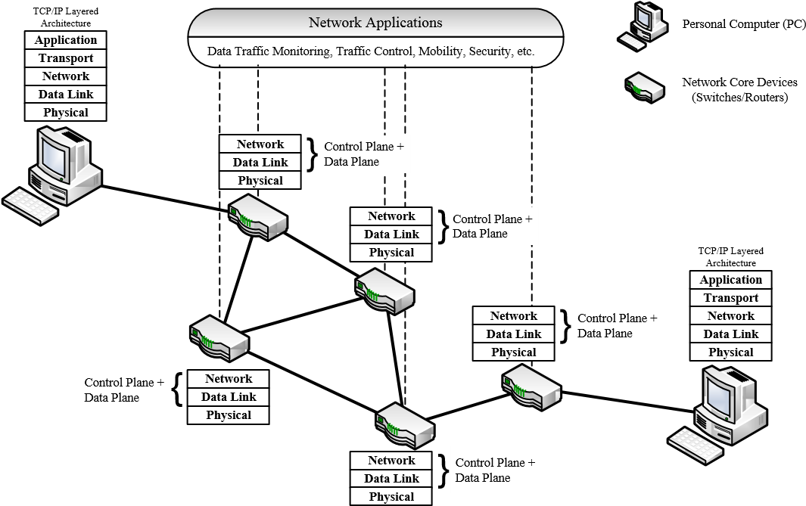

Figure 2.1 Simplified Traditional Network Architecture
To improve the challenges that occurred in traditional network architecture and its technologies, a new ongoing network paradigm, SDN, is introduced. The new paradigm of a network separates the network architecture into the data plane and control plane. By this separation we can manage the network centrally by using controllers. SDN is a type of programmable network that gives a solution to traditional network in different ways. That is first, it separate control plane from data plane devices such as switches and routers those are used to transfer data. This decoupling of the two planes breaks down the problem of vertical integration, which is more simplified for management. Secondly, with the separating of the control and data planes all the network management task is centrally controlled by a software-based controller which is, NOS and also the data plane devices are responsible for the forwarding of the traffic [10]. SDN architecture between devices is shown in Figure 2.2 [11].
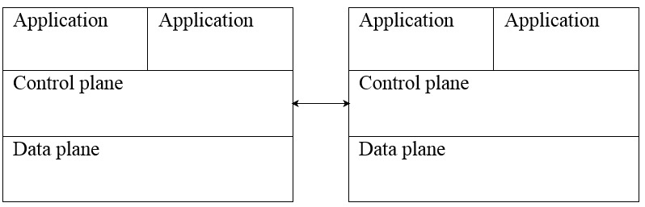
Network device A Network device B
Figure 2.2 SDN Architecture
SDN is better than the traditional IP based network from different perspectives such as availability, management of the network, maintenance cost, utilization of the controller and resources, and also it is more agile and programmable than a traditional network. Due to this, we considered SDN for WAN to reduce global latency and increase performance. In the next section, we will review SDN introductory concepts, the architecture of the SDN and more specifically focus on the core idea of the research which is the CPP.

Software Defined Networking

Overview of the Software Defined Networking
As an ongoing and new network paradigm that solves problems found with traditional IP based network SDN is now considered as the promising approach for future network technologies. This new paradigm of network separates the control and data planes to promote logical centralization of network control and central network programming ability. This decoupling of layers network allows for a separate controller entity that may change the data forwarding rules in OpenFlow switches and facilitates greatly the deployment and operations of services which are new and also enables SDN to react kindly to the change network demands and modifications of the topology [12]. It breaks the vertical integration by separating control plane from data plane. With this separation, routers and switches become forwarding devices which are simple and the control logic can be implemented in a logically centralized controller. This logically centralized controller is responsible for tasks such as network configuration, policies enforcement, management of the topology flow table entry and discovery of the link [13].
In SDN, since the controller has a global view of the network, it can easily add and delete policies and rules dynamically. It is also able to drop a malicious attack that affects the network. This new network can reconfigure the network-based requirement from network operators which can add and delete packet forwarding devices. It is also easier to manage the network and easy to add functionality for the network. Only the first packet of each new flow will arrive at the controller. Based on this packet, the controller defines the rules for forwarding devices such as routers and switches. The next incoming packets of this new flow check the flow table entries that are stored in Ternary Content Addressable Memory (TCAM) and forward packet to next forwarding devices [1].
One of the most significant advantages of SDN is the intelligence of the network is centralized in controllers which are software-based in which the network appears to applications that highly define network design and operations. The centralized control layer facilitates optimization of the network resources and network management in which the logical centralization of SDN can be achieved either by a single controller or by multiple controllers.

Architecture of Software Defined Networking
The idea of SDN architecture is used to decouple the data and control planes, including a uniform vendor diagnostic OpenFlow interfaces between the two layers, by centralizing network intelligence into the high-performance unique device which is known as controller. This architecture has a logical map of the entire network and also the network functions in the application layer which provides efficient control and monitoring of the network. This new architecture of the network allows the implementation of a programmable, scalable, and flexible network that overcome the limitations of the traditional network [14]. The overall SDN Architecture is shown in Figure 2.3 [14].
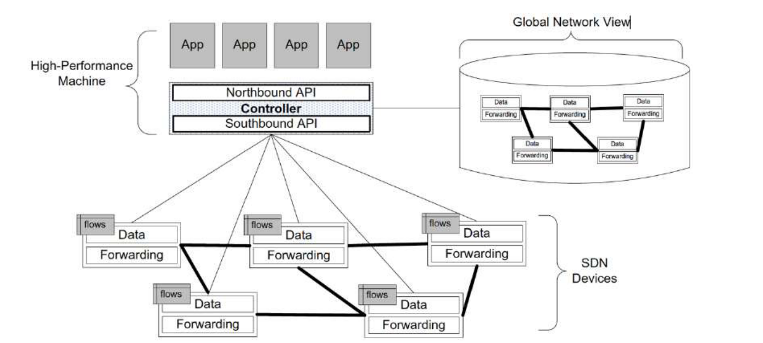
Figure 2.3 Overall Architecture
This architecture has three planes called management plane, control plane and data plane. Management plane connects application with control plane. Control plane controllers forwarding devices, switches and routers. The data plane layer used to forward packets. Figure 2.4 shows detailed layers of SDN architecture[1].
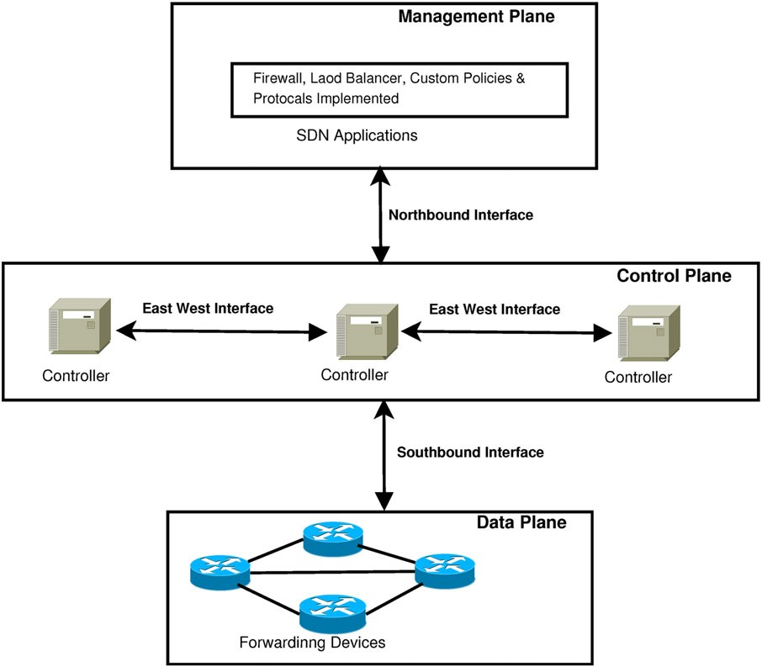

Figure 2.4 Detailed Layers of SDN Architecture
In this architecture, the SDN controller is a centralized and executes SDN software and manages data plane by communicating with it through the protocol which is known as OpenFlow, in which controller transmit different rules to the data plane based on the dynamic needs such as policies which are new, network events and alerts. In this communication, a data plane has a simple role that is forwarding a given packet to the next node based on the simple rules provided by the controller. This controller and data plane communication increase the overall performance of the network [11].
The architecture has different interfaces, which include three different planes such as management plane, control plane, data plane, and three interfaces like Northbound interface (NBI), East‐west interface protocol, and southbound interface. In this next subsections, we discuss the details of those planes and interfaces, as stated in [1].
Management Plane: It is an application plane which is responsible for setting and defining rules and policies for the network, which includes security, monitoring, load balancing, routing, firewalls, and traffic management. The controller communicates with the application plane through an Application program Interface (API), NBI, in which SDN applications directly, explicitly and programmatically communicate with the network and request the controller.
Control Plane: It is the centralized server that responsible for the programming of data plane devices by defining the set of rules and policies and acts as the brain for the network in which it has a globally complete view of the network.
It is responsible for tasks like connection setup to data plane devices, proactive flow programming, and installation of forwarding rules to the data plane layer. Also, it manages building a network view, maintain route selection and availability of the data plane on the network.
Data Plane: This plane includes both physical and virtual forwarding devices such as switches and routers, which are interconnected either by wireless or wired network medium. It is a simple plane to forward packets based on the route given in the flow tables for every device and also complex algorithm is not executed in this plane. The flow table includes a header, match, and action.
Northbound Interface: It is an interface that provides the necessary support for communication between management and control planes. This interface provides instructions that are level for the southbound interface and do not have standardized protocols those defined for it.
East‐West Interface Protocol: It is the interface that provides protocols that are used to manage the multiple controllers’ communication especially in distributed controllers which are used to enhance the performance of the network.
Southbound Interface: It is a standard protocol for SDN, which is a control to data plane interface (CDPI) that provides support for the communication between the data and control planes.

Single and Distributed Controllers

Single Controller
Although the implementation of SDN using a single controller is possible and good, it has several challenges related to scalability due to the limited resources of the controller at the time of handling a large number of requests, and also it has robustness issues due to single point of failure [15].
A single control plane has benefits such as controlling the centralized network node and abstracting network infrastructure easily, but it has drawbacks on issues such as scalability and reliability. To overcome the limitation of single SDN controller limitation it is better to deploy multiple distributed SDN controller in which this deployment distribute the load among controllers equally and handle failures of nodes by taking over when another controller crashes [13].

Distributed Controllers
SDN with multiple controllers refers to SDN with more than one controllers that working together for the enhancement of performance, availability, and scalability. Large-scale network and heterogeneous SDN need to be divided into several sub-domains, and those domains require a minimum of one controller [16]. There are many benefits that multiple controllers provide.
Administration: The single controller capability is limited with the comparison with multiple controllers, especially in the management of large scale network. The collaboration of multiple controllers improves the management efficiency for multi-domain and heterogeneous networks due to the different features they have.
Scalability: The approach of the current OpenFlow may lead to an overload of the single controller, which decreases the network scalability. But the multiple controllers’ architecture is a practical solution, so that controllers can be added and deleted dynamically and requests can be load balanced to solve a single point of failure which is the demerit of the single controller.
Latency reduction: If all event is responded successively by a single controller, it cause the controller overload and increase latency. So, to solve this problem it is better to use multiple controllers in which it balances load among controllers and reduces latency.
Robustness: Since the multiple SDN architecture adopts multiple backup it avoid a single point of failure and also it increases the network robustness. When one controller fails others hold switches related to it and load balancing takes place to maintain network stability, performance and also reduce the network failures which occur due to controllers’ failure.

Challenges of Multiple SDN Controllers
Although SDN with multiple controllers has many advantages and overcome drawbacks of a single controller, it comes up with new challenges such as consistency, placement, and scheduling [17]. Challenges occurred due to multiple controllers summarized as the following:
Consistency: Multiple controllers’ platform, synchronization of network information controllers, is a critical issue that relies on consensus algorithms such as Paxos and Raft. Now current mechanisms of consensus are not completely suitable due to low availability, incremental latency, and implementation complexity in multiple controllers that need more scientific work [17].
Controller Placement: CPP is a crucial issue in the multiple architectures of SDN. It answers questions like how many controllers are necessary and where to place them. Although these two issues are vital, Nondeterministic Polynomial (NP)-hard problems and the aspect of the placement problem like latency reduction and load balancing are the challenging issues [18].
Scheduling: Although network performance is improved by using multiple controllers, it is challenging to schedule multiple controllers to handle single controller overload, how to balance overloaded controllers quickly as much as possible, and adaption of the control plane to uneven distribution of loads when mapping with switches [13].

Architecture of Distributed SDN Controller
Distributed architecture is used to effectively improve the controllers’ scalability since it has multiple architectures rather than a single controller. It is both horizontal and hierarchical architectures.

Horizontal Architecture
In this architecture, all the controllers connected into disjoint domain by flat model. Controllers manage their network with equal state and communicate together in parallel by using their east-west interfaces. All controllers are mastering the network as a root controller when the topology of the network changes all the controllers upgraded without complicated operations synchronously. Since all the controllers act as root controller, it wastes the resources and increases a load of controllers when the network is updated. This architecture includes controllers such as Onix, HyperFlow, and FlowVisor [19]. For detail, we showed the horizontal architecture in the Figure 2.5 [13].
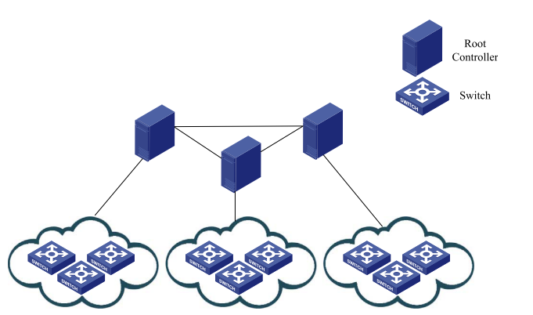
Figure 2.5 Horizontal Architecture

Hierarchical Architecture
In this architecture controller, classified into the root and local controllers hierarchically in which local controllers are close to switches and responsible for the network state in their domain, and root controllers are responsible for maintaining the whole network state information. This architecture is shown in Figure 2.6 [13].
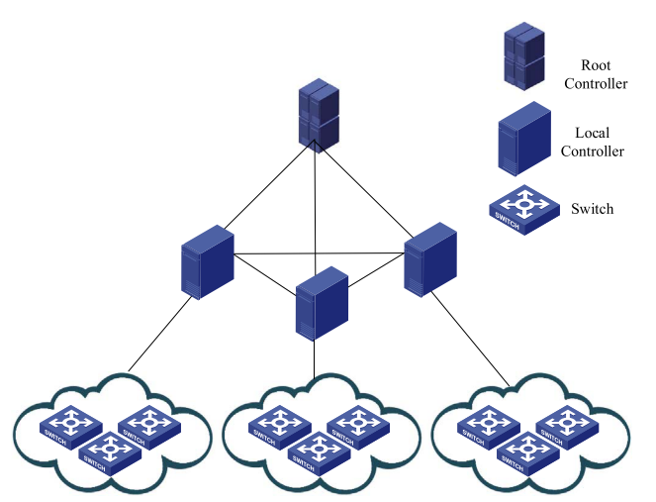
Figure 2.6 Hierarchical Architecture
Since the distributed controller is better than a single controller by a number of significances as we reviewed above in the benefits of distributed controllers over a single controller section. Due to this, we focused on the distributed controller in which we specifically do our research on one of the main challenges of distributed controllers known as controller placement, which affects performance, scalability, availability, and robustness of distributed controllers. In the next section, we have discussed a distributed controllers CPP issues.

Controller Placement Problem
CPP is a fundamental research problem in the software-defined network. It is not an issue for small-sized and medium‐sized networks since one controller is enough to manage these types of network. The objective of CPP is to place an optimum number of controllers in a network to achieve better performance. In large-sized networks, we should consider multiple controllers and placement of these controllers by using the optimized method. CPP is a combinatorial problem that is known as the NP-hard problem. Placing the controller at any random position would increase the overhead delay of service, which led to a decrease in the overall performance of the SDN infrastructure [1]. To solve this problem, many researchers came up with several assumptions. They did experiments with different solution approaches by considering different types of networks based on the size of coverage, which is data center and WAN, and based on other types like wired and wireless networks [15].
Although SDN brings many benefits, the separation of data plane and control plane causes CPPs. This problem leads to the poor performance of the network, especially in WAN. Most of the researchers consider the propagation latency between the switches and the controllers while ignoring switch weights. Only considering propagation latency cause load imbalance among the controllers. Some controllers will be overloaded and always be in high-speed operation while other controllers are underutilized. The main two ways of controller placement in SDN are centralized and distributed controllers’ placement. A centralized controller placement results in a single point of failure. Once a controller is attacked, the network is paralyzed and its security becomes poor. Multiple controllers’ placement divide control plane into multiple domains. This sub-division improves the performance, load balancing, robustness, and prevent failures of the network.
CPP has become a hot research area in current research in SDN because the location and number of controller to be deployed have a high impact on the network performance in multi-controller network architecture. Due to their characteristics, difference data centers and WANs have difference solutions of CPP. In WAN, the goal of controller placement is for finding the suboptimal feasible solution in a limited time by reducing its search space, whereas in the data center network it is used to get optimal solution with high performance [20].
Other researchers [21],[7] stated that in WANs because of a large number of switches, it is challenging to solve CPP exhaustively in a limited time. So, the researchers used heuristics algorithms to reduce the search space and to ensure rapid convergence to a near-optimal controller placement, although some metrics such as load balancing are not considered.
As stated by other researchers, [2] controller placement that based on the clustering method is better in efficiency than a non-clustered method, such as heuristic approaches, since it consumes large search spaces. In clustering-based controller placements, a large network is subdivided into domains that reduce the complexity of network management for the partitioned large network [1].
Therefore, since clustering-based controller placement has better performance than non-clustered methods, we use it for controller placement in our study. We have discussed several clustering methods as input for our research and comparisons with each other methods in the next section.

Clustering Algorithms
Clustering is a means to identify data groups which show the same characteristics. Partitioning is a method to divide the data group. Objects within a group have more similar properties than objects in another group [22]. Clustering algorithms are classified into partitioning method, hierarchical method, grid-based method, density-based method, and model-based clustering methods. We discuss in detail those algorithms as follows.
- Partitioning Methods: It constructs k-partitions of the data in which each partition represents a cluster that satisfies that each group must include one object, and each object must belong to one group. It is a scalable and simple method to cluster data points [23].
- Hierarchical Methods: It creates hierarchical decomposition of the given data objects, which is either agglomerative or divisive based on its formation. The divisive approach is the top-down approach that starts with all objects in a similar class. The second approach is an agglomerative bottom-up approach in which clustering starts every object forming a different cluster, and it merges continuously objects that are close to each other [6].
- Density-based Clustering Methods: It is a noise and outlier dependent clustering algorithm that is based on density. Switches with the highest density and these have a near distance to each form the same single cluster and so on. The switches have low density and unable to group to a given cluster form their own independent cluster [6],[7].
- Model-based Methods: Hypothesize a model for every cluster and find for data that is the best fit for a given model and locate clusters by constructing a density. It leads to determining clusters number based on standard statistics taking into account noise and outliers to get strong clustering methods [6].
- Grid-based Methods: Quantize the space of the object into cells that are finite in number which forms a grid structure. Its advantage is a high speed of processing time which is only dependent on the cell number in every quantized dimension and independent of the number of data objects [6].
We considered the partitioning based clustering method for CPP since it is scalable and simple relative to the rest methods. In this partitioning based clustering, when K number of cluster is given, these partitioning based methods start by first creating K initial partitioning. It then updates and improves the centres based on methods and groups the object into different clusters in which objects of the same cluster close to each other [24].In the following Table 2.4, we compare and contrast the main known partitioning based clustering algorithms with their advantages and limitations.

Table 2.1 Comparisons of Partitioning Algorithms
No: | Algorithm | Pros | Cons
 | K-means[25] | Cluster is represented by centroid and very fast. | Sensitive to outliers and Noise.
 | K-median [26] | Select centre based on the mean; therefore, it is not sensitive to noise and outliers. | There is no closed-form which used to determine every dimension median. It needs to integrate with different methods.
 | K-medoid [23][25] | Cluster is represented by medoid, and it is not affected by noise and outliers. | It consumes high time. Random selection of initial medoid leads to different data.

Based on the advantages and limitations of these known partitioning based clustering algorithms, we focus on the study of the K-medoid clustering algorithm since it is insensitive to noise and outliers in comparison to other algorithms and its application in CPP. Moreover, we study the limitations of the K-medoid algorithm, especially medoid initialization, since it is using a random initialization method that consumes a lot of time. So in this study, our main focus is using the K-medoid algorithm for optimization of the CPP of the given network topology. For better performance enhancement of CPP, we have improved the algorithm by reducing medoid initialization time from O(n$\log{n}$) to only O(n) [50]. In the next section, we discuss the related works of CPP to come up with a better solution.

Related Works
In this section, we have reviewed research works done on the areas of CPP. It includes latency between switch and controller, latency between controllers, load balancing, determining a minimum number of controllers, way of controller placements, clustering-based issues for controller placement, heuristics algorithms which have used and need to be optimized for controller placement.
Applying performance objectives like load balancing, reliability, resistance awareness, and energy-saving to the subnetworks that is clustered network is better than the whole non-clustered network. This method reduce the complexity of the CPP [27].
The study on a controller placement [18] introduced CPP and proposed a heuristic approach to find a position of a controller which is optimal in large scale SDN deployments in which average-case latency is considered to determine latency values in large-scale SDN deployments. This approach primarily depends on the propagation latency, in which the location of the controller is based on the shortest path distance between switches and controllers. And they concluded that an increasing number of controllers does not necessarily decrease average latency. But, the researchers did not consider load balancing among controllers, which causes failure of the problem in the network.
Other researchers [7] stated that the heuristic method used is less performed than clustering based placement of controllers since the heuristics-based method has a drawback of an optimal local solution and consuming a lot of time. They also stated that the density-based approach for placing controllers by clustering in which worst-case and average latencies with better performance, fault tolerance for links, and nodes which independently done is better in comparison with Pareto-based Optimal Controller placement (POCO) and Mini-Cut. But load balancing, which causes failures of nodes and affects the performance of distributed controllers, are not considered.
Other researchers [27] proposed an optimized k-means algorithm to partition the network into sub-networks by focusing on the minimization of maximum latency between centroids and respective nodes. They did an analytical presentation of network partitioning. They did better in minimizing latencies for different topology in comparison with the standard k-means algorithm which led to better performance and also, they stated that it is better to apply metrics such as load balancing, energy, and reliability and resistance awareness to a clustered network than a network that is not clustered. However, these researchers didn’t focus on load balancing among controllers at the time of clustering. They only focus on maximum latency efficiency between controllers and switches without considering latency between controllers.
The study on distributed clustering of controllers [2] did good work to minimize the required number of controllers and tried to analyze controller load. Although they reduce the number of controllers and analyze load, they used iterative algorithms for searching, which consumes a lot of time. And also, they did not consider a load balancing in their study.
The research on mini cover-based controller placement [28] study the reliability of controllers which is affected by link failure and deciding a minimum number of controller of controllers. But they did not consider average and maximum latency between switch and controllers. They did not consider latency between controllers and balancing load of controllers in their study.
The study was done on the delay, and load-based controller placement [29] stated a total flow request cost considering the switch weights and inter-controller delays for controller placement. They also consider the load balance between controllers in the condition in which topology is known. The optimal controller position was obtained. But those researchers do not consider clustering based controller placement. As mentioned in some papers above since clustering based is high performed for controller placement by considering load balancing.
Another CPP study [30] that done on the reliability improvement for controller placement which is better placement by the regular algorithms. But they did not consider average latency and load balancing in the study. Lastly, another researcher [6] did study optimal controller placement by using standard K-medoid in POCO. In the study, the average and maximum latency between switches and controllers. And also, the average latency between controllers is considered. But the method used in this study consumes a lot of time for the medoids initialization. Controller placements metrics such as average and maximum latency considered. The researcher doesn't consider the maximum latency between controllers. Table 2.5 shows related work with gaps.

No | Objective | Year of Publication | Method Used and Strength | Limitation of the Study
1 | Placing controller and reduce latencies [18]. | 2012 | Considers placements’ average and maximum latency. | Load balancing among controllers, which reduces latency, is not considered.
2 | Optimized k-means algorithm-based network partitioning [27]. | 2016 | They used k-means to minimize centroid to nodes latency. | Affected by noise and outliers, Do not focus load balancing in partitioned subnetworks.
3 | Optimizing of the network average reliability by controller placement [30]. | 2016 | Improving reliability for controller placement | Latencies between node and controller, also between controllers, are not considered, load balancing not issues that they use for controller placement.
4 | Clustering-based controller placement to reduce latency and number of packet loss[2]. | 2017 | They reduce the number of controller topology. | But they did not consider the load balancing.
5 | Optimal controller placing of controllers in the network for the efficiency of latency by considering load balancing [6]. | 2018 | The standard K-medoid algorithm is used for controller placement considering.  The study considers the load balance ,N2C average and maximum latency | The method consumes a lot of its time to initialize centroids for controller placement. This latency affects performance metrics.  The maximum C2C latency is not considered in this study. The minimum number of controllers is not optimum.
Table 2.2 Summary of Related Works

Summary
In summary, although many SDN based multi-controller placement methods have been proposed in recent years, the above methods still suffer from certain shortcomings. As mentioned above, although clustering based controller placement is better than heuristics based methods, most of the researchers did it without considering load balancing for controller placements and others used methods that require a number iterations to search for nodes which consume much time. Most researchers consider the delay between the switches and the controller, and ignore the critical factor in the actual network, load balancing, in which ignoring it leads to poor performance and increases the network failures. Other researchers ignore latency between controllers and load balancing simultaneously. Another gap of some study is the method used is poor, which consumes high search space and affects the metrics such as average and maximum latency.
Therefore, based on the above-stated gaps of the related works, we have proposed a controller placement for ethio-telecom WAN network topology by using an optimized K-medoid clustering algorithm. In this study, we have included multiple metrics such as average and maximum case latency between switch and controllers, latency between controllers, load balancing for controllers. Moreover, it focuses on optimizing the algorithm for performance enhancement and overcome gaps of some researchers. Lastly, we determine a minimum number of controllers and optimum positions of controllers for the topology which is not considered by many researchers of CPP in SDN. Next in chapter three, we discuss methodology used for the research to solve CPP for the proposed.

CHAPTER THREE

Research Methodology

Introduction
We have discussed research methods to conduct a controller placement study for the topology. Moreover, study of the existing method to get a good understanding of the proposed method, data collection approaches, and the proposed solution design, the proposed solution implementation and testing methods, and research design are described.

Research Design
Research is described as an approach to promote knowledge. The activities of research design begin with problem formulation and move on with suggestions on how to solve it. Development and evaluation is proceeding with a possibility of moving back to the problem formulation stage [31].
To attain the objectives of the research, answer the research questions, and design our research, we have used the procedures and techniques shown as the following:
- First, we have identified the area and the problem to be solved.
- Second, we have started the research questions to be answered.
- Third, to do this, we have reviewed different articles, journals, books, and sites.
- Fourth, we have identified the required parameters to model the solution and then design the proposed solution.
- Fifth, we have prepared the experimental environment using Matlab and POCO tool to conduct the experiments.
- Sixth, we have documented the result that we get by using Matlab and POCO tool.
- Finally, we have analyzed the results and evaluated the performance of the proposed method by calculating the running time of the algorithm based on our metrics in comparison with the existing methods. Figure 3.1 shows the research procedure discussed above in a diagram.
Identify the area and
Problems
Research questions
Literature reviews
Design the Proposed
Solution
Experiment setup for
The proposed solution
Implement the
Proposed Solution

Conduct the
Experiment
Result analysis and
Evaluations
Identifying research
Gaps and
Show future directions
Figure 3.1 Research Design Procedures

Controller Placement Methods
Several methods for controller placement are exist based on types of network, and performance metrics considered. These methods include clustering based, and heuristics based controller placements [15].
In this study, we have used a clustering based method, optimized K-medoid, for optimal placement and load balancing of controllers. Moreover, this algorithm is used to reduce latency and gain an optimal number of controllers needed for a given topology. We have proposed the method since the determination of the optimum location of controllers in a large scale WAN is till the significant target in SDN research, and load balancing with clustered network.

Data Collection Approaches
Data collection approaches are used to explain the process of collecting data. It enables researchers to answer the relevant questions, to evaluate the outcomes and make predictions. Those approaches are used to develop effective strategies [31].
In our research to collect the transport network datasets of ethio-telecom, we used interviews and existing documents for data collection.
Interview: By using interviews, data about the existing network of ethio-telecom is collected. We have interviewed the company’s network division manager and experts. Interview questions are attacked in the appendix in the interview questions section.
Documents: We have collected documents that have all information about the network from authorized higher authorized officials. We have used it for a detailed study of the network controller placement. Due to confidentiality of the company, we have not included the details of the transport network topology into our document based on the agreement we have signed.

Proposed Solution Design
The solution has been designed to analyse the network dataset input for controller placement. In the next section, we have discussed the design tools.

Design Tools
We have used different types of tools for this research to design the proposed solution. It includes the EdrawMax tool and draw.io online tool to design various diagrams.

Proposed Solution Implementation
The designed solution has been implemented by using the POCO Matlab tool. The optimized algorithm was prepared by using Matlab programming. The network topology file in GRAPHML and Geography Mark-up Language (GML) are prepared by using XML programming language and GML respectively. Then we have integrated it into the POCO simulator in a Matlab.

Experimental Setup and Implementation Tools
In the next section, we discuss working environments that include both software requirements and hardware requirements.

Working Environments
Software, hardware requirements and programming language have used are discussed in the next sections.
Software Requirement
  - Operating System: Windows operating system.
  - Matlab Version: MATLAB R2018a.
  - Matlab Editor: Matlab programming editor is invented by David Garrison and provides a new way to create, edit and run MATLAB® code. It is used to view results and evaluate the result.
  - Notepad++ Editor: It is used for preparing the .gml and .graphml file.
Hardware Requirement
  - Processor: Intel® Core™ i7-4700 CPU @ 2.40GHz 2.40 GHz
  - Installed Memory (RAM): 8.00GB
  - System Type: 64 –bit operating system, x64-based processor.
  - Hard Disk:1TB
Programming Languages
- Matlab: We used Matlab programming for creating interfaces for network topology upload, calculate the shortest distance, for clustering of the given topology file, for controller placement, to calculate latency metrics, for load balancing, and also for evaluation of the results.
- C Programming: We have used c programming for algorithm optimization by integrating with Matlab.

Proposed Solution Evaluation Methods
This CPP solution for Ethio-telecom and its evaluation is developed by using the POCO tool by using average N2C latency, maximum N2C latency, average C2C latency, maximum C2C and load imbalance. After placing controllers into the topology by using the proposed method, we evaluate the metrics such as latency and load imbalance and compare it with the existing method. For comparisons of the three algorithms, we used Matlab workspace for evaluation of the result.

Research Methodology Development
Quantitative research often deals with experiments, whereas qualitative research can use procedures such as field studies [31]. We have used both quantitative and qualitative research methods in which we can solve how the proposed algorithm is expected to support solutions to the problems. We have used qualitative research to deal with the description and understanding of the situation behind the CPP issues and data study and the quantitative research for performance metrics, numerical analysis of result, and show relationships between CPP metrics for evaluation of the study.

Summary
In this chapter, we have discussed the research design, controller placements methods, data collection approaches, solution design approach and tools used, the proposed method implementation, evaluation methods, and the research methods. In the next chapter, we discuss the details of the optimized K-medoid method for controller placement.

CHAPTER FOUR

Optimized K-medoid Algorithm for Controller Placement

Introduction
In this chapter, we discuss the proposed method for controller placement which includes modeling of solution for the problem, optimizing the standard K-medoid algorithm to partition the network and optimize controller placement. Furthermore, we have discussed placing of controllers into the topology to improve average and maximum latency between switches and controllers, latency between controllers, determine a minimum number of controllers, and decide optimum positions. Formulation of the CPPs is also discussed.

Modelling the Controller Placement Problem
In this section, we have discussed the model of the CPP. It includes activities such as preparing topology structure from datasets, read GRAPHML file, extract latitude and longitude, convert it into a matrix, clustering of topology nodes, the optimum positioning of controllers, load balancing, and calculating latency between node and switch, and also latency between controllers. The proposed model have better time efficiency in comparison with existing models. Figure 4.1 shows the details of the controller placement model.
Are all Nodes Clustered?
Start
Prepare Topology Structure G (V, E)
Read Topology GraphML file
Extract Latitude and
Longitude then convert (X, Y) matrix
Clustering of Nodes by Optimized
K-Medioid

No
Placing of Controllers
Load Balancing
Calculating Latencies and Load
Imbalance
End
Yes

Figure 4.1 Controller Placement Model

Prepare Topology Structure
To prepare the topology structure for controller placement, we have used the transport network dataset collected from the ethio-telecom network division. We have collected latitude and longitude of the nodes, switch weights, number of edges, and number of nodes, and also the direction of each node in the transport network.
We have prepared the GRAPHML file format of the dataset by using an XML programming language that represents the topology mathematically by G (V, E). We have considered the GRAPHML file since the POCO supports it for controllers placement. We have also prepared a GML format of the topology to depict its details by using coordinates with its names. In G (V, E), V represents the sets of switches, and E represents the sets of links that connect these switches.

Read GRAPHML
After preparing the topology by using collected datasets, the GRAPHML read into the POCO tool for controller placement.

The Proposed Method for Controller Placement
In this section, we have discussed the standard K-medoid algorithm for clustering and its limitations. Moreover, we have discussed in detail the optimization of the existing algorithm for better efficiency and to improve the performance of CPP for the topology.

Standard K-medoid algorithm
In this section, we discussed the standard K-medoid algorithm with its limitations. K-medoid is a clustering technique that divides a set of n objects into a user given k number clusters. It is a type of the partitioning based clustering algorithms which is insensitive to outliers and noise, as discussed in chapter one.
The principle of this algorithm is to reduce the sum dissimilarity between each object and its respective reference points. The algorithm starts its work by randomly choosing k objects from the given dataset. Then it assigns an object to the nearest cluster by considering object distance and medoid [32]. Algorithm 4.1 shows the standard K-medoid algorithm.
Algorithm 4.1 Standard K-medoid Algorithm

Standard K-medoid Algorithm
←
1: procedure [inds, cidx] Kmedoid(D,k)
2: input D n dataset
←
3: Output K K Clusters
←
4: n size(D,1)
←
5: cidx Randomperm(n)// initialize medoid by random permutation
←
6: cidx sort(1:k)
←
7: while true do
8: inds ← assign pts clusters(D,cidx) // nodes to closest medioid
9: [cidx] ← update centers(D,inds,k) // update medioids
10: End loop
End Procedure
11: procedure inds assign pts clusters(D,cidx)
←
12: S D(cidx)
←
13: [vals, inds] min(S,[], 1) // assign nodes to closest medoids
←
End Procedure
14: procedure inds update centers(D,inds,k,pts)
←
15: for all i 1 k do
← −
16: indsi find(inds i)
← ←
17: [minind] min(sum(D(indsi,indsi),2)) // minimum distance
←
18: cidx(i) indsi(minind) // nodes to closest center
←
End loop
End Procedure

Although this algorithm has several advantages, it consumes a lot of time for the initialization of the medoid. The standard K-medoid algorithm used random permutation to initialize medoid. The complexity of a random permutation algorithm is O(n * log(n)) [33]. This time complexity needs further improvements.
We focused on the optimization of the algorithm for controller placement to get better efficiency in average and maximum latency between switches and controllers, and also latency between controllers. The existing algorithm optimized by using the Knuth shuffling algorithm for medoid initialization and we have used it for network controllers placement.

Knuth Shuffling Algorithm
The Knuth shuffling algorithm is a simple algorithm to generate a permutation of n items uniformly without retries. The algorithm starts with any permutation and then goes through the positions 0 through n-1 where n is the maximum position. It consumes only O(n) time complexity to initialize medoids [34].
There are several algorithms these we can use for initialization of medoids. It includes Linear Congruent Method, Knuth Shuffling algorithm, Naive Algorithm, Pseudo Random Generator algorithm, and Brute Force algorithm. We have compared these algorithms based on their time complexity. Researchers in [35] states that the Knuth algorithm is 11.8 faster than Linear Congruent Method in efficiency. The rest algorithms are discussed in Table 4.1 [34],[36], [37].

Table 4.1 Comparison of Algorithms to Optimize Standard K-medoid
Algorithm | Time complexity
Knuth Shuffling algorithm | O(n)
Naive Algorithm | O(n²)
Pseudo Random Generator Algorithm | O(nlog^{n})
Brute Force algorithm | O(n²)
In the study, for optimization of the standard K-medoid algorithm we have selected the Knuth shuffling algorithm based on its performance in comparison with another algorithms as described and shown above. We have used Knuth algorithm to improve the existing algorithm’s medoid initialization. The optimized K-medoid algorithm is used to optimize the CPP by improving network performance. Algorithm 4.2 shows the detail of the Knuth shuffling algorithm.
Algorithm 4.2 Knuth Shuffling Algorithm

Knuth Shuffling Algorithm
1: procedure mexFunction( )
2: data p mxGetPr(p) // to get first address of pointer p
←
←
3: data r mxGetPr(r) // to get first address of pointer p
4: for all n- 1 0 do
5: mwSignedIndex j floor((i+1) data r[i]) // distributing j for i
←
←
←
← ∗
6: tmp data p[j] //assign permutation j p[j] to assign
7: data p[j] data p[i] // swap picked element with permutation p[i]
8: data p[i] tmp // swap picked element with permutation p[j]
End loop
End Procedure
9: procedure KnuthShuffle(())
10: p (1:n)
←
11: r rand(1,n) // returns random generation given matrix
←
12: mexFunction(nlhs, *plhs[], nrhs, *prhs[])
End Procedure
In this algorithm arguments such as nlhs represents number of output variables, plhs represents array of mxarray pointers to the output variables, nrhs represents number of input variables, and represents prhs array of mxarray pointers to the input variables.

The Optimized K-medoid Algorithm
We have discussed the optimized K-medoid algorithm, how the Knuth algorithm is used in the standard K-medoid to optimize in this section. The Knuth shuffling algorithm is integrated into K-medoid for optimization of the standard K-medoid algorithm by reducing time complexity for medoid initialization. Algorithm 4.3 shows the proposed optimized K-medoid algorithm.
Algorithm 4.3 Optimized K-medoid Algorithm

Optimized K-medioid Algorithm
1: procedure mexFunction( )
2: data p mxGetPr(p)
←
←
3: data r mxGetPr(r)
4: for all n- 1 0 do
5: mwSignedIndex j floor((i+1) data r[i]) // distributing j for i
←
←
←
← ∗
6: tmp data p[j] //assign permutation j p[j] to assign
7: data p[j] data p[i] //swap picked element with permutation p[i]
8: data p[i] tmp // swap picked element with permutation p[j]
End loop
End Procedure
9: procedure KnuthShuffle( )
10: p (1:n)
←
11: r rand(1,n) // returns random generation given matrix
←
12: mexFunction(nlhs,*plhs[],nrhs,*prhs[])
End Procedure
13: procedure [inds, cidx] Kmedioid(D,k)
←
14: input D n dataset
←
15: Output K K Clusters
←
16: n size(D,1)
←
17: cidx KnuthShuffle(n) // initialize medioid using Knuth Shuffle
←
←
18: cidx sort(1:k) // sort initialized medioids from smallest to largest
19: while true do
20: inds ← assign pts clusters(D,cidx) // assign closest medioid
21: [cidx] ← update centers(D,inds,k) // update medioids
22: End loop End Procedure
23: procedure inds assign pts clusters(D,cidx)
←
24: S D(cidx)
←
25: [vals, inds] min(S,[], 1) // assign nodes to closest medoids
←
End Procedure
26: procedure inds update centers(D,inds,k,pts)
←
27: for all i 1 k do
← −
28: indsi find(inds i)
← ←
29: [minind] min(sum(D(indsi,indsi),2)) //minimum distance
←
30: cidx(i) indsi(minind) // nodes to closest center
←
End loop End Procedure
We have used the optimized K-medoid algorithm to increase the controller placement performance by enhancing the efficiency of some metrics such as average and maximum latency between switches and controllers, and latency between controllers for the given network topology. The optimized algorithm result approval details are shown in chapter five, in comparison with the existing algorithms. Figure 4.2 shows the optimized algorithm model.
Initialize Medoids by
Knuth Algorithm
Assign Nodes to
Closest
Medioid
Update Medioids with
the lowest Cost
Are all Nodes
Updated with
Lowest Cost?
Start
End
Yes
No
Figure 4.2 Optimized K-medoid Algorithm

Controller Placement Problem Formulation
In this section, we discussed mathematical modeling of the CPP from the perspectives of an average and maximum latency between switch and controller, latency between controllers, and also load imbalance metrics. Before going to model mathematical equations for measurement of the above metrics, the mathematical symbols used and their description is shown in Table 4.2.

Table 4.2 Mathematical Symbol with Description
Symbol | Description
G(V, E) | Undirected network graph
V | Set of nodes in the graph
E | Set of edges in the graph
Uv | A bidirectional link between two nodes
d_{u,v} | Represents the latency of the link
K | Number of controllers that distribute across the network
P | Number of placements

The functions used to calculate latencies and load imbalance with its details are represented in Table 4.3.
Table 4.3 Metrics Functions Representation
Functions | Description
π^{average N2C-Latency} | Average Node to Controller (N2C)latency
π^{maximum N2C-Latency} | Maximum N2Clatency
π^{average C2C-Latency} | Average Controller to Controller (C2C) latency
π^{maximum C2C-Latency} | Maximum C2C latency
π^{load} imbalance | Load imbalance

The metrics have considered for controller placement include average latency between nodes and its controller, maximum latency between nodes and controllers, average latency between controllers, maximum latency between controllers, and load balancing. We have discussed the formulation of problems for the above metrics in the next section.

Latency
It is one of the main frequently used metrics for the measurement of performance of the network [15]. It can be classified as a switch to controller latency and controllers to controllers' latency. We have considered the average switch to controller latency, maximum switch to controller latency, average C2C latency and maximum C2C latency our study. The details and mathematical modelling of the latency metrics discussed.

N2CLatency
N2Clatency provides connectivity information about the node and its assigned controller. It includes average and maximum latency.
The Average N2CLatency
Average N2C latency represents the average packet transmission delay value between a node and its assigned controller to reflect propagation delay[20]. The mathematical modeling of the average N2C is shown in Equation 4.1.
π^{average N2C-Latency=}$\frac{1}{|V|}\sum_{vεV}{\left(\min_{p∈P}d_{v,p}\right)}$ 4.1
Maximum N2C Latency
Maximum N2C latency refers to the latency that represents the maximum packet transmission delay value between the node and its assigned controller. This latency is usually the optimal objective in a strict constraint and a high-performance environment [20]. Mathematically the maximum N2Clatency is shown in Equation 4.2.
π^{maximum N2C-Latency=}${\max_{v∈V}min}_{pєP}d_{v,p}$ 4.2

Controller to Controller Latency
The controllers communication is the crucial task used to achieve network state consistent view for better network operation. The communication that is used to maintain a shared state between controllers is essential [20]. C2C latency measures delay between two controllers.
The average Controller to Controller Latency
Average C2C latency is the average packet transmission between controllers [20]. The average C2C latency mathematically is shown in Equation 4.3.
π^{average C2C-Latency=}$\frac{1}{|P|}\sum_{p1,p2εP}{\left(d_{p1,p2}\right)}$ 4.3
The maximum Controller to Controller Latency
The maximum C2C latency is the maximum packet transmission between controllers [20]. The maximum C2C latency mathematically is shown in Equation 4.4.
π^{maximum C2C-Latency=}${\max_{p1,p2∈P}d}_{p1,p2}$ 4.4

Load Imbalance
It is the difference between the maximum number of switches assigned controller and the minimum number of switches assigned controller. It is the process of migrating switches among controllers in each cluster to balance traffic load [38]. The minimum load imbalance value is better to enhance performance by reducing latency. Load imbalance is shown in Equation 4.5.
π^{load} imbalance=$\max_{p∈P}$n_{p}- $\min_{p∈P}$n_{p,} 4.5
where n_{p} represents number of nodes assigned to controller p.

Summary
In this chapter, we have discussed the proposed solutions modelling. The existing algorithm limitations and the optimized K-medoid algorithm are also seen in detail. We also discussed the way of optimizing the existing algorithm. Lastly, we have discussed the CPP formulation. In the next chapter, we discuss the simulation of the network for controller placement, results for three algorithms, evaluation and discussion of the results.

CHAPTER FIVE

Result, Evaluation and Discussions

Introduction
In this chapter, we discuss the environment used to conduct an experiment on controller placement for the ethio-telecom WAN by optimized K-medoid based. Moreover, we discussed the simulation result, discussion and evaluation of the proposed method will made in detail. The controller placement result for the network topology is shown by using a different number of the controller. The number of tested controllers ranges from two to nine based on metrics used for performance measurement. Lastly, we discussed the controller placement by comparing the two algorithms with the optimized K-medoid algorithm. The metrics such as average N2C latency, maximum N2C latency, average and maximum latency between controllers, and load balancing are considered for measurement of the topology performance.

Simulation Tools
In this section, we have discussed the experimental setup and tools. We have used some tools to conduct experimental work for ethio-telecom network for CPP optimization and improve performance of the network.
The main SDN simulation tools include Matlab and Simulink, POCO Matlab based tool, Mininet network emulator, Network Simulator Version 3(NS3), OFnet (OpenFlow Network) and Estinet 9.0 network simulator. These tools are discussed one by one.

Matlab Simulink
Matlab Simulink is a MATLAB tool that doesn’t provide OpenFlow support and can be extended for SDN support [39]. This tool is not comfortable for controller placement.

POCO Tool
It is used for CPP which provides a suitable and simple for calculating, analysing and illustrating controller placement. It considers multiple metrics for multi-objective controller placement. It is also used for evaluation of the given topology [40].

Mininet Network Emulator
Mininet is a network simulator that is used to create virtual hosts, controllers, switches and links realistic networks. It is a great tool to develop an experiment with OpenFlow and SDN, and is also used to run a Linux network [41]. Mininet manages SDN tasks such as creating, customizing and testing. But, for placing of SDN controllers, it is challenging to use it [42].

Network Simulator Version
Network simulator is a discrete event and open-sources that most widely used as simulation tools of a network. It provides OpenFlow support to support SDN [39].

OpenFlow Network
OFnet is similar to a Mininet. It is used to monitor OpenFlow messages and evaluate the performance of the controller. Even if its GUI is attractive, it supports less in comparison with Mininet [39].

Estinet 9.0
It is a novel commercial simulation and emulation tool, which is best OpenFlow in the world for doing SDN research [43]. Table 5.1 shows the known SDN simulations tool comparisons.
Table 5.1 SDN Simulation Tools Comparisons
Simulation Tool | Descriptions
Matlab Simulink | Used for signal based tasks such as transmit signal, deploy, and prototype it. We can develop controller placement by using this tool. But, it requires more since it should start from the beginning. It doesn’t have a framework for controller placement
Mininet Network emulator | It is SDN emulator that is used to create virtual switches, hosts, controllers, and links. It is used to develop real network topology.
NS3 | Used to internet systems and provides OpenFlow support. It doesn’t support CPP.
OFNet | It provides an environment for OpenFlow and to develop network topology. Used to create real topology rather than solving CPP.
Estinet 9.0 | Best OpenFlow network simulator and emulator in the world for doing Software Defined Networks research. We can use it for the development of real network topology.
POCO tool | It is SDN simulation tool that is used for controller placement, which provides a convenient and simple method to calculate, analyse and illustrate controller placement with attractive GUI.
As we have discussed in Table 5.1, some of these SDN tools have functionalities to deploy real SDN network where others support for CPP in SDN. Matlab and Simulink, and POCO are used to solve CPP in the SDN. The former does not give a framework for controller placement it needs bulky programming.
We have selected the POCO tool to solve the CPPs for ethio-telecom WAN since it is the most convenient tool for controller placement among tools discussed in Table 5.1. The details of the POCO tool are shown in the next section.

Simulation Tasks
The simulation activities we did are a simulation of data set using GML and GRAPHML format for topology preparation, POCO simulation for controller placement.

Preparation of the Topology
In this section, the GML and GRAPHML based ethio-telecom topology are prepared for to make it comfortable for controller placement.

GML based Topology Preparation
GML is a geographic form of programming that used to prepare graph which has edges, nodes with their names and details. We have used it to depict details of the topology in a graph. Figure 5.1 shows the full ethio-telecom network topology prepared for controller placements by using GML. It shows details of full topology and its edges, nodes with its names, and all adjacent nodes. We have used the GML topology format to show the details of ethio-telecom topology.
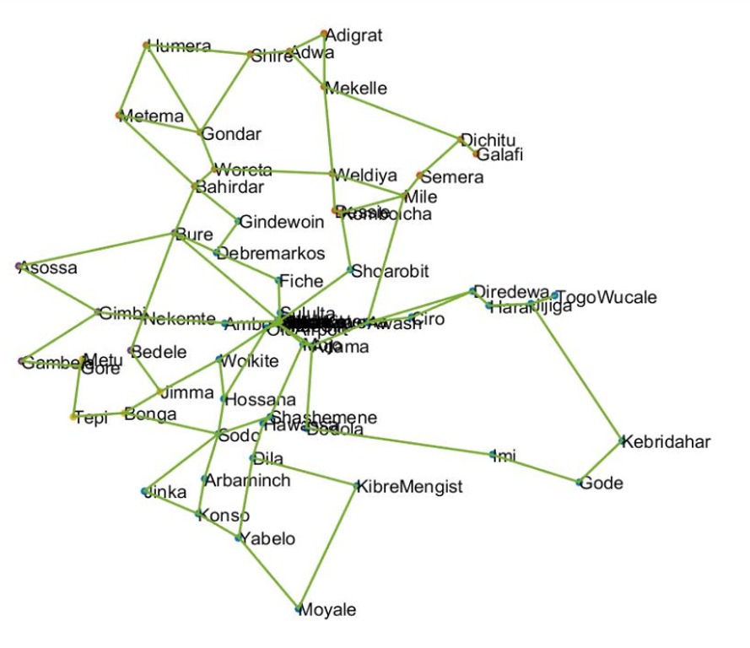
Figure 5.1 GML Format Based Ethio-Telecom Network
The invisible nodes in the Figure 5.1 are shown in Figure 5.2.

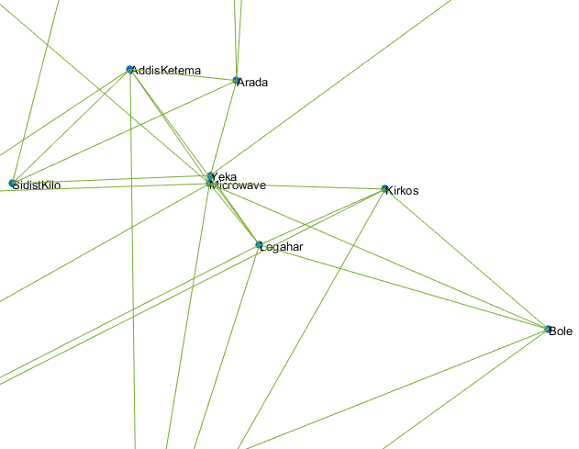

Figure 5.2 Invisible Part of the Topology

GRAPHML Based Topology Preparation
Before going to see the details of GRAPHML based topology, we have discussed the integration of topology with the POCO framework.

Integration into the POCO Framework
The POCO tool is a framework that is based on the Matlab for optimal placement of the controllers in SDN. Both the POCO GUI and its detail are implemented by using Matlab open-source. The performance metrics for all possible placements can be accessed from the GUI of the framework in which each placement is represented as metrics in the x and y-axes. The points that are located on the Pareto frontier with respect to the metrics are highlighted and connected with line segments. The center of the framework represents the topology location area of the undirected graph. Currently, controllers are represented with triple circles, and the color of each node is based on the traffic light color scheme, represents the latency to the node’s controller based on the lowest distance.
On the right side, some checkboxes allow enhancing the graphic information. It includes the load imbalance with coloring to show node-to-controller assignments for analysis based on the algorithm, different latency metrics between controllers, and also latency between nodes and controllers. At the bottom part of the GUI, the Pareto frontier for all placements in the x-axis and y-axis all possible metrics are visualized, and a user can select those metrics in both axes based on use cases used. We have shown these issues in Figure 5.3 in details.
We have integrated the proposed algorithm into the framework for easy implementation of controller placement of the ethio-telecom transport network. We also have used the framework to evaluate the given topology placements for controllers and provide a visualization of the solution space using GUI.

GRAPHML Topology Preparation
Figure 5.3 shows POCO tool with GRAPHML based topology and different metrics for controller placement.
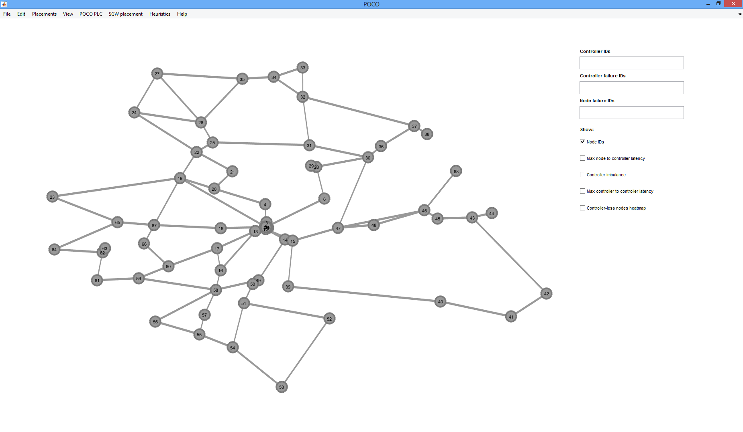
Figure 5.3 POCO Tool GUI with Topology and Metrics
After uploading the topology, we integrated the optimized algorithm into the framework for the controller placement determination purpose. We used GRAPHML format to prepare the topology which used to solve CPP. The format is used since it is compatible with the framework. This POCO framework is designed to simplify the CPP as stated by researchers in [40], [44].
Therefore, we designed the ethio-telecom network topology by using GRAPHML programming. Figure 5.4 shows the representation of the ethio-telecom WAN transport network by using GRAPHML. Invisible nodes in Figure 5.4 are shown in Figure 5.2.
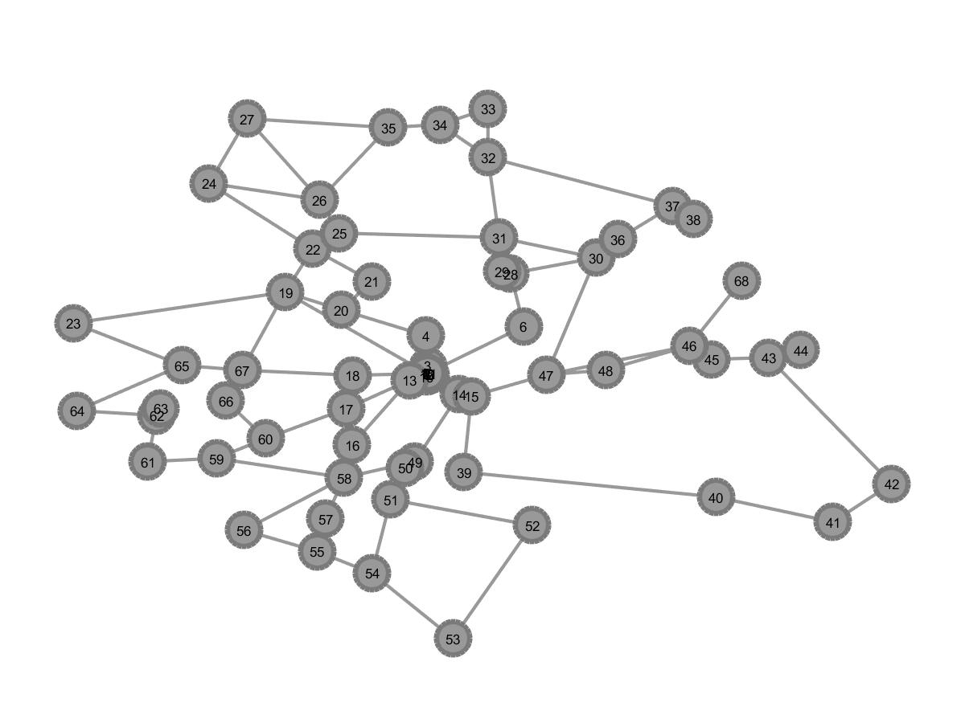
Figure 5.4 GRAPHML based Ethio-telecom Network Topology

Controller Placement Simulation
In this section, the simulation of the controller placement for the ethio-telecom transport WAN on the POCO tool. Furthermore, results had shown from the perspectives of average and maximum latencies between switch and controllers, average and maximum latencies between controllers, and load imbalance by using an optimized K-medoid algorithm.
We have evaluated the result by using these metrics and compare the proposed method with standard K-medoid and simulated annealing algorithms (PSA). The experiment takes place by using a number of K controllers from two to nine. We did the results of this scenario step-by-step based on the type of algorithm used.

Simulation and Result
In this section, the controller placement simulation and result for the topology is discussed for the three algorithms separately simultaneously. In this result illustration latency is represented by seconds and load imbalance is represented by decimal. To discuss results we converted latency to millisecond and decimal load imbalance into percent by multiplying with 100. The controller placements simulation and results are discussed for the PSA, standard K-medoid and optimized K-medoid algorithms in the next sections.
For the study documentation we have considered four and seven numbers of controllers since seven is optimum number of controllers of optimized method. But, we have tested number controllers from two to nine and put all results on the appendix. We have also used two to nine number of controllers for performance evaluation and to determine minimum number of controllers and optimum positions.
We have selected number controllers from two to nine since less than two number cannot be clustered and no need of controller placement. Also we have simulated up to nine controllers, but the optimum controller for the topology is found at seven. So, we stop our testing at nine controllers.
Another issue is justification of metrics selection for the study. We have selected average and maximum N2C latency, average and maximum C2C latency and load imbalance based on the gaps of the studies in the related works and for the purpose studying multi-objective controller placement.

PSA based Controller Placement Simulation
Pareto simulated annealing is a metaheuristic local search algorithm that used for the optimization of global combinatorial problems to come up with solutions near to optimal [45].

Four Controllers
In this section, we have discussed placement of four controllers for the topology. For this method the positions for controller placement include Nifas-Silk, Woreta, Kebridahar and Arbaminch. Figure 5.5 shows the placement of four controllers by using the PSA algorithm.
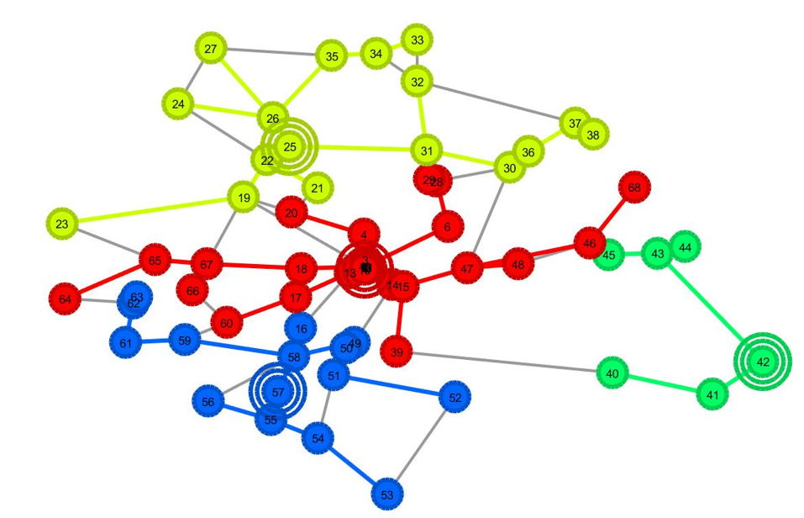
Figure 5.5 Placing Four Controller by using PSA
Figure 5.6 shows N2C average latency, N2C maximum latency, C2C average latency and load imbalances results after placing four controllers. The result for average N2C latency is 0.134, maximum N2C latency is 0.3537, average C2C latency is 0.3236 seconds, and load imbalance is 0.6029.
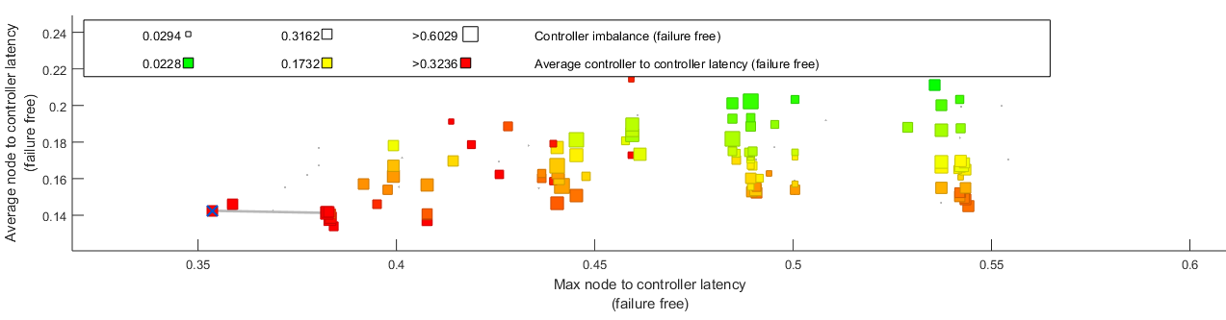
Figure 5.6 Latencies and Load Imbalance using PSA where k=4
Figure 5.7 shows maximum latency between controllers, after placing four controllers. The maximum latency between controllers is 0.6775 seconds.
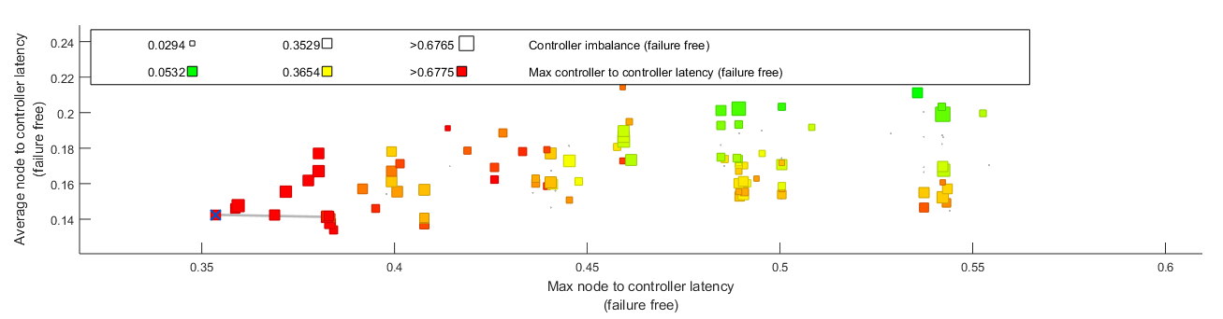
Figure 5.7 Maximum C2C Latency using PSA where k=4

Seven Controllers
Figure 5.8 shows placement of seven controllers into the topology by using the PSA algorithm. Based on this method positions for controller placement include Bahirdar, Weldiya, Imi, Awash, Dilla, Bonga and Moyale.
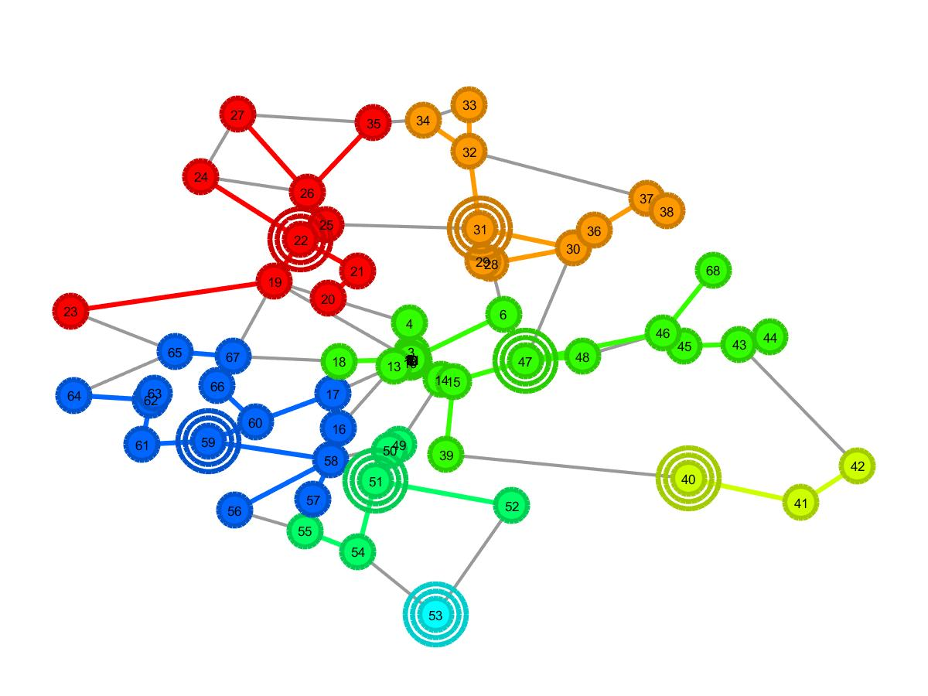
Figure 5.8 Placing Seven Controllers by using PSA
Figure 5.9 shows result for the average N2C latency, maximum N2C latency, and average C2C latency, and load imbalance by placing seven controllers using PSA algorithm. The result for average N2C latency is 0.0927, maximum N2C latency is 0.2522, average C2C latency is 0.3791, and load imbalance is 0.3676.
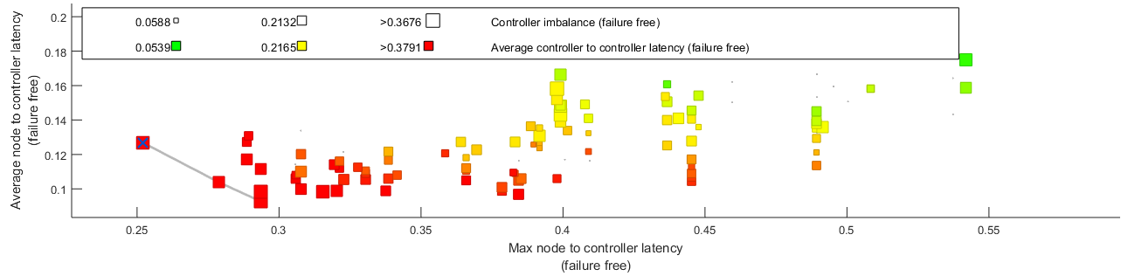
Figure 5.9 Latencies and Load imbalance using PSA where k=7
Figure 5.10 shows result of maximum latency between controllers for the topology by placing seven controllers using PSA algorithm. The maximum latency between controllers is 0.7894 seconds.
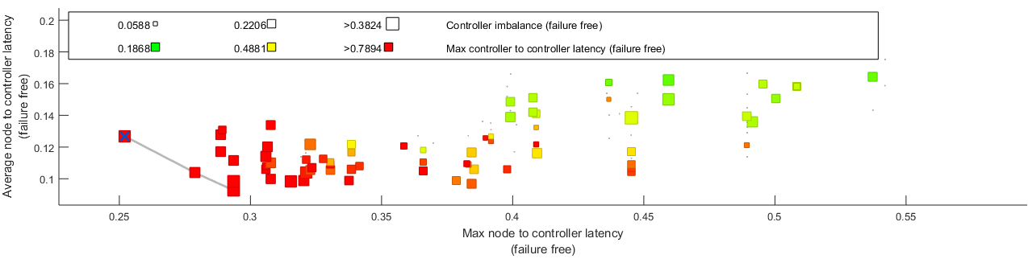
Figure 5.10 Maximum C2C Latency using PSA where k=7

Standard K-Medoid Based Controller Placement Simulation

Four Controllers
Figure 5.11 shows the placement four controllers into the topology, by using the standard K-medoid algorithm. Based on this method the positions for controller placement are Bahirdar, Nifas-Silk, Sodo and Mile.
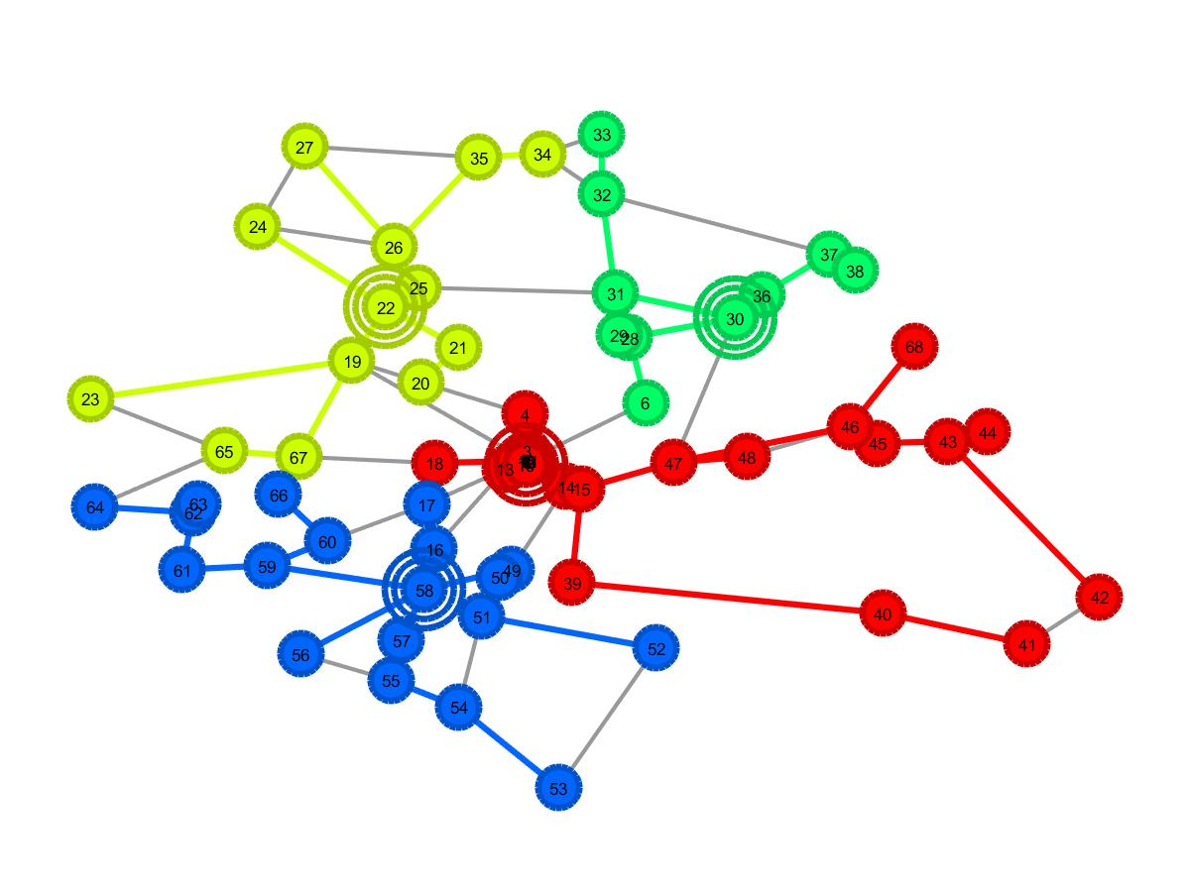
Figure 5.11 Placing Four Controller by using Standard K-medoid Algorithm
The Figure 5.12 shows N2C average latency, N2C maximum latency, and C2C average and load imbalances result for the topology by placing four by using standard K-medoid algorithm. The result for average N2C latency is 0.134, maximum N2C latency is 0.3966, average C2C latency is 0.3383, and load imbalance is 0.1765.
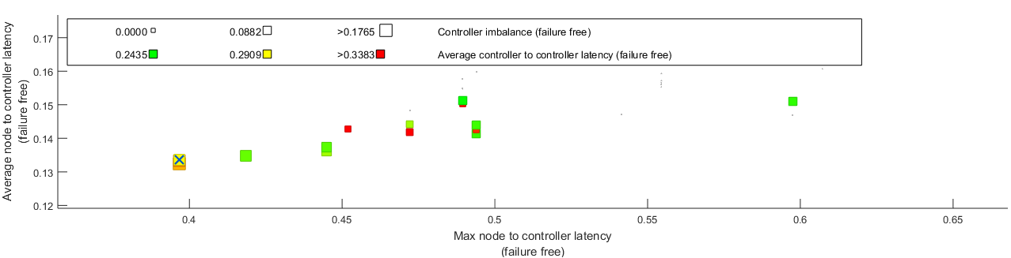
Figure 5.12 Latencies and Load imbalance using Standard K-medoid where k=4
Figure 5.13 shows the maximum latency result between controllers. The maximum C2C latency is 0.6067.
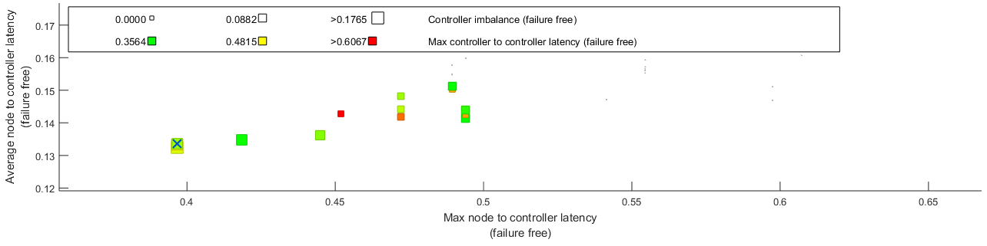
Figure 5.13 Maximum C2C Latency using Standard K-medoid where k=4

Seven Controllers
Figure 5.14 shows the placement of seven controllers into the topology by using a standard K-medoid algorithm. By using this method the positions for controller placement include Adwa, Bahirdar, Sodo, Legahar, Awash, Harar and Gode.

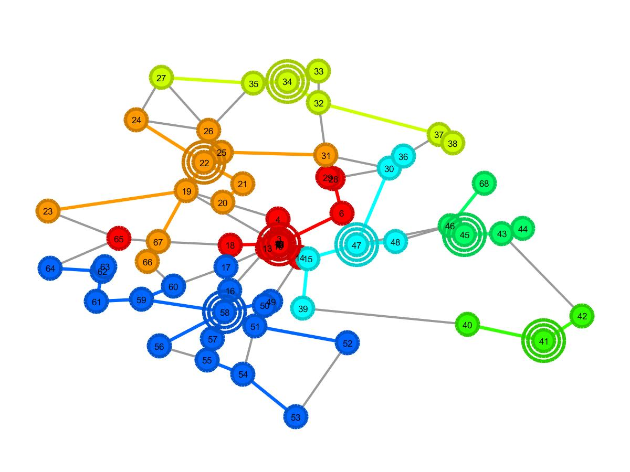
Figure 5.14 Placing Seven controller using Standard K-medoid
Figure 5.15 shows average N2C latency, maximum N2C latency, average C2C and load imbalance result by seven controllers using standard K-medoid algorithm. The result for average N2C latency is 0.0870, maximum N2C latency is 0.2787, average C2C latency is 0.3741, and load imbalance is 0.2206.
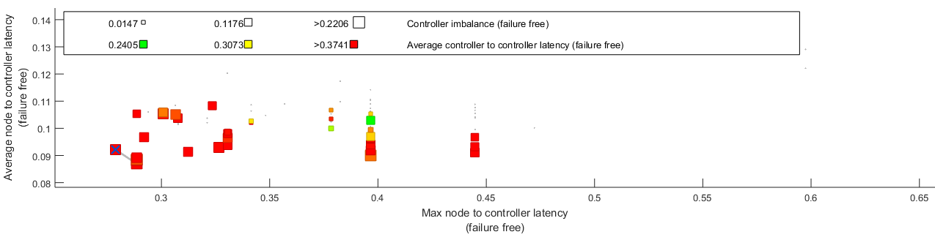
Figure 5.15 Latencies and Load imbalance using standard K-medoid where k=7
Figure 5.16 shows the maximum latency result between controllers for the topology where a number of controllers is seven by using standard K-medoid algorithm. The maximum C2C latency is 0.7853.

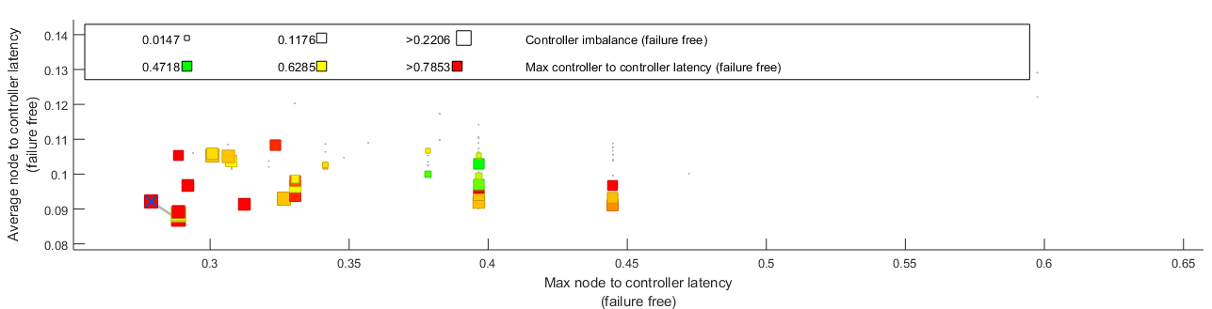
Figure 5.16 Maximum C2C Latency using Standard K-medoid where k=7

Optimized K-medoid based Controller Placement Simulation
It is the new optimized algorithm extended from the standard K-medoid algorithm by using Knuth shuffling algorithm.

Four Controllers
Figure 5.17 shows the placement of four controllers into the topology, by using an optimized K-medoid algorithm. Based on this method the positions of controllers include Nifas-Silk, Bahirdar, Mile and Sodo nodes.
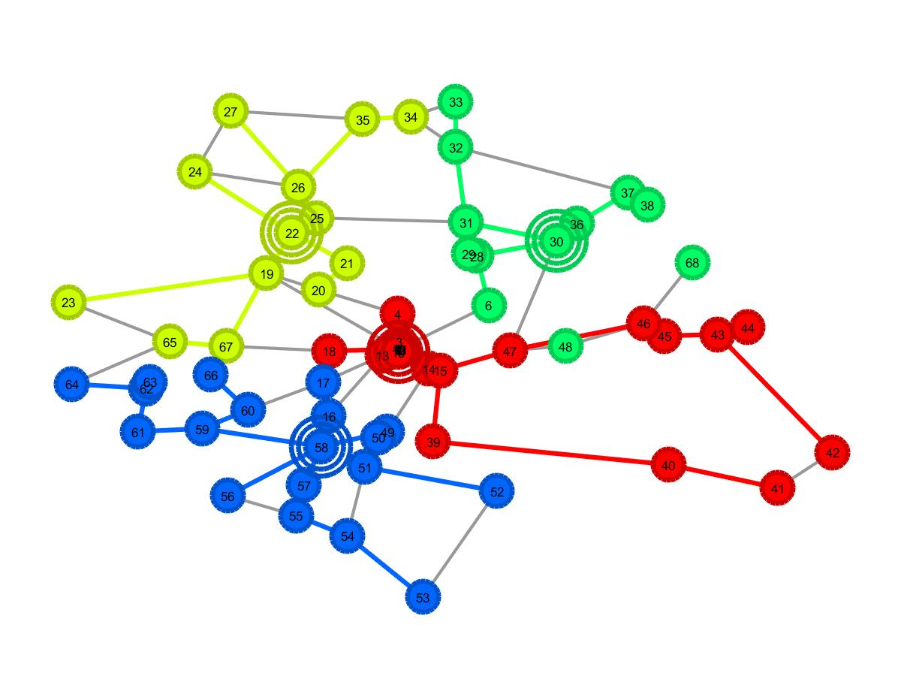
Figure 5.17 Placing Four Controller by using Optimized K-medoid
Figure 5.18 shows N2C average latency, N2C maximum latency, C2C average and load imbalances results for the topology by placing four controllers using an optimized K-medoid algorithm. The result for average N2C latency is 0.134, maximum N2C latency is 0.3966, average C2C latency is 0.3195, and load imbalance is 0.1765.
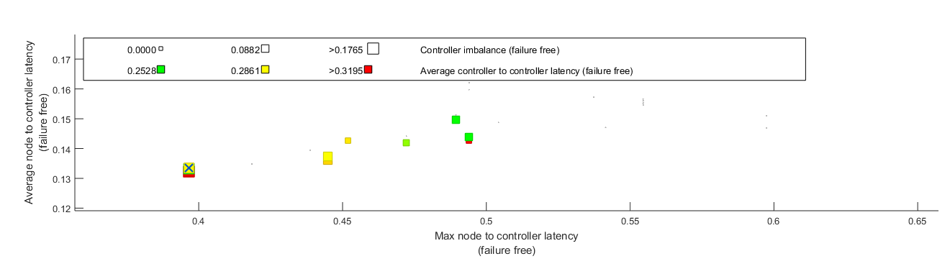
Figure 5.18 Latencies and Load imbalance using optimized K-medoid where k=4
Figure 5.19 shows maximum latency result between controllers for the topology, where a number of controllers is four by using an optimized K-medoid algorithm. The maximum C2C latency is 0.5309.
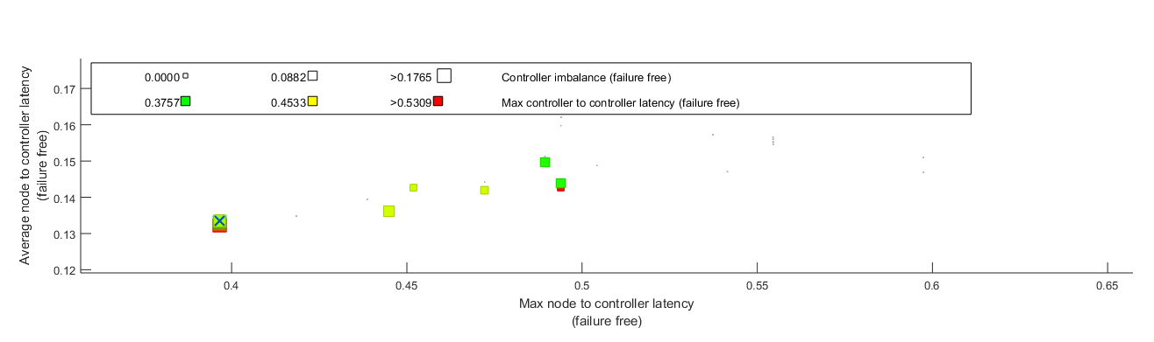
Figure 5.19 Maximum C2C Latency using Optimized K-medoid for k=4

Seven Controllers
Figure 5.20 shows placing seven controllers into the ethio-telecom by clustering it into seven clusters using an optimized K-medoid algorithm. By using this method the positions of controllers are at nodes 8, 30, 35, 43, 54, 61 and 67. These nodes represent Legahar, Mile, Tepi, Jijiga, Shire, Nekemte, and Yabelo.
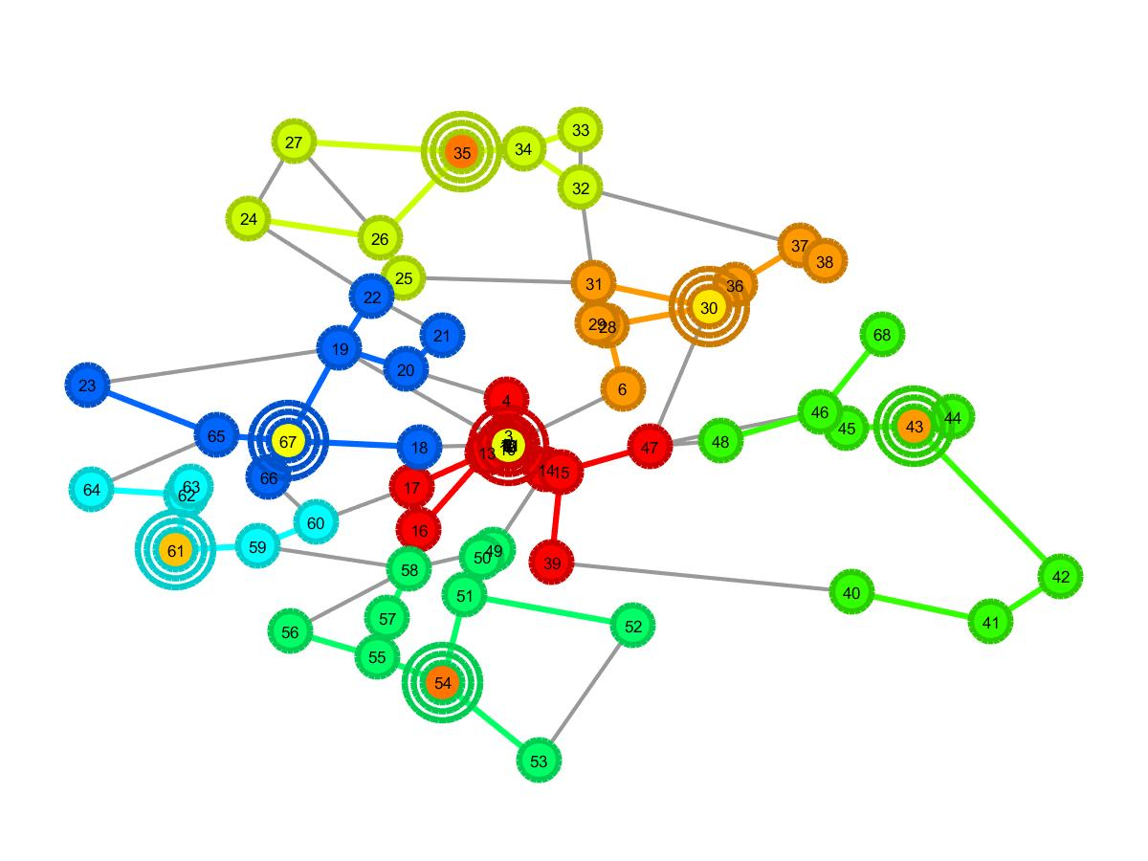
Figure 5.20 Placing Seven Controllers by using Optimized K-medoid Algorithm
Figure 5.21 N2C average latency, N2C maximum latency, C2C average and load imbalances result for the topology where a number of controllers are seven by using an optimized K-medoid algorithm. The result for average N2C latency is 0.087, maximum N2C latency is 0.2416, average C2C latency is 0.3673, and load imbalance is 0.2206.
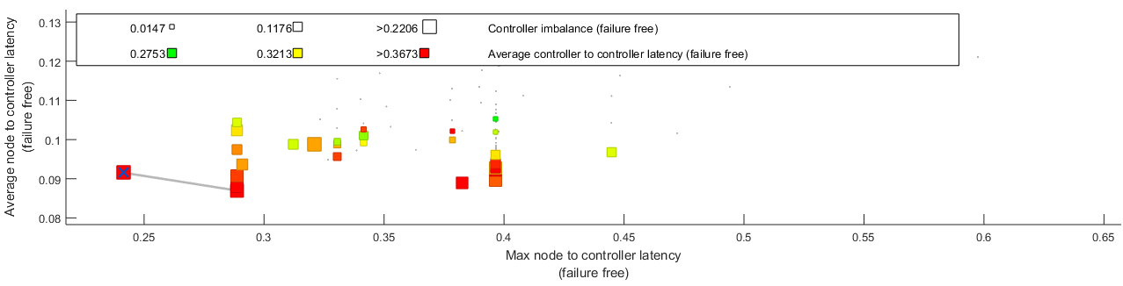
Figure 5.21 Latencies and Load imbalance using optimized K-medoid where k=7
The maximum latency result between controllers for the topology, where a number of controllers is seven by using an optimized K-medoid algorithm, is shown in figure 5.22. The maximum C2C latency is 0.6771 seconds.
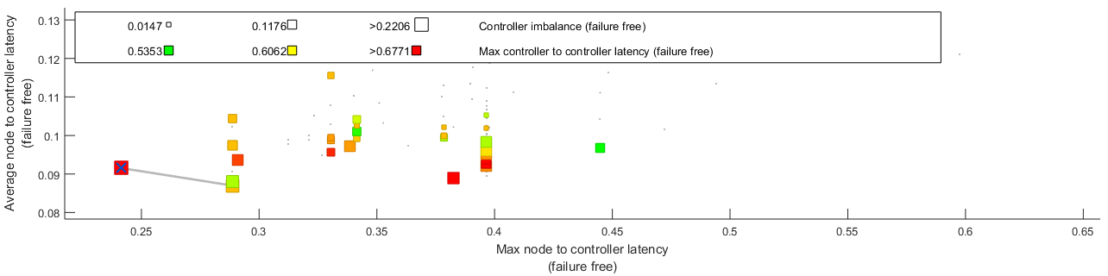
Figure 5.22 Maximum C2C Latency by using Optimized K-medoid Algorithm for k=7
In the next section, we have evaluated the result of the three methods and discussed an improvement of the optimized algorithm.

Evaluation
To evaluate placement results for the three algorithms, we have used the output from the POCO tool. The evaluation of the methods is based on the average N2C latency, maximum N2C latency, average C2C latency, maximum C2C latency, and load imbalance.
Figure 5.23 shows the average N2C latency results for the three methods, by considering two to nine number of controllers. The figure also shows as a number of controllers increases the optimized K-medoid algorithms performs most efficiently starting from controller number seven in comparison with the two methods.

Figure 5.23 Average N2C Latency
Figure 5.24 shows the maximum N2C latency for two to nine controllers. In this case, the result reveals that as the number of controller increases, the optimized K-medoid algorithms performs in the most efficient value of N2C average latency starting from seven number of controller.

Figure 5.24 Maximum N2C Latency Results
The Figure 5.25 shows the average C2C latency for two to nine using the three methods. In this case as the number of controller increases the optimized K-medoid algorithms performs in the most efficient value of C2C average latency. Especially starting from six number of controllers the proposed method performs with best value.

Figure 5.25 Average C2C Latency Results
Figure 5.26 shows the maximum C2C latency results by considering number controllers from two to nine for the three methods. Starting from seven number of controllers the proposed method perform in best efficiency.

Figure 5.26 Maximum C2C Latency Results
Figure 5.27 shows the load imbalance results by using number controllers from two to nine for the three methods. This Figure show load imbalance rate for controllers’ two to nine for the three algorithms. Most probably the K-medoid and optimized K-medoid algorithms have similar value of load imbalance which is near to the recommended standards of load imbalance.

Figure 5.27 Load Imbalance
Determining Minimum Number of Controller
Determining minimum number of controller is reduce the deployment cost of controllers. Before going to determine the minimum number of controllers we have defined the standards for the recommended latency between nodes and controller, and also load imbalance assignment between nodes and controllers. WAN supports latency up to 250 ms between nodes and delay more than 250 ms cause talk-over [46] . Also as stated by 250 ms is [46] the maximum roundtrip latency. As stated by [6],[18] and [47] the recommended average latency for WAN is less 250 ms with shared mesh network. And also the range of recommended load imbalance assignment between near to 20 %.
We have tested controller placement of the three algorithms. In this experiment we have considered two to nine number of controllers. Starting from seven controllers the optimized algorithm performing better in all latency metrics. For seven number of controllers, average N2C latency is 0.087 second ,which is 87 ms and maximum N2C latency is 0.2416 second, which is 241.6 ms. Since these latencies between node and controllers is less than 250 ms it is optimum value. And also the load imbalance is near to 20 % which is 22.06 %.
Although the k-medoid algorithm’s N2C average latency is the same to the optimized K-medoid algorithm and it is in a recommended range, its maximum N2C latency is 0.2787 seconds which is 278.7 ms. This maximum N2C latency is greater than 250 ms. Hence it is not recommended for controller placement. The average and maximum N2C latency by using PSA algorithm are 92.7 ms and 252.2 ms respectively. The maximum N2C is greater than the recommended range, even though average latency is in this recommended range. By using K-medoid and PSA algorithm it is consumes a lot of time. So, these algorithms requires more controllers to optimize these latencies.
Improving performance metrics
Another issue is in our study is improving the CPP metrics. The metrics we have considered for the study includes average and maximum N2C latency, average and maximum C2C latency. Table 5.2 shows results of multiple performance metrics for the three algorithms.
Table 5.2 Performance Metrics Output
No | Performance Metrics | PSA Algorithm | Standard K-Medoid Algorithm | Optimized K-Medoid Algorithm
1. | Average N2C Latency | 0.0927 | 0.087 | 0.087
2. | Maximum N2C Latency | 0.2522 | 0.2787 | 0.2416
3. | Average C2C Latency | 0.3791 | 0.3741 | 0.3673
4. | Maximum C2C Latency | 0.7894 | 0.7853 | 0.6771

The proposed method improves these metrics with best efficiency in comparisons with PSA and standard K-medoid algorithms as shown in Table 5.3 based on the result shown in the Table 5.2.

Table 5.3 Performance Improvement of the Proposed Method
Metrics Improved | PSA Improvement by (%) | Standard K-medoid Improvement by (%)
Average N2C Latency | 6.15 | 0
Maximum N2C Latency | 4.2 | 13.31
Average C2C Latency | 3.11 | 1.82
Maximum C2C Latency | 14.23 | 13.78

Therefore, the proposed method improves average latency between node and controllers by 6.15% for PSA. Maximum N2C latency is improved by 4.2 % for PSA, and by 13.31 % for standard K-medoid algorithms. Average C2C latency is improved by 3.11 % and 1.82 for PSA and standard K-medoid algorithms respectively. Lastly, the improvement of maximum C2C latency for PSA is by 14.23 % and for standard K-medoid algorithm is by 13.78 %.

Discussion
The evaluation of results crosscheck with the recommended standards indicate that the optimized K-medoid algorithm is the best method to determine the minimum number of controllers for the ethio-telecom network. Since the optimized method latency between nodes and controllers, and load imbalance are within the recommended ranges by using seven number of controllers, the recommended minimum number of controllers for ethio-telecom network should be seven. The minimum number of controllers save cost to deploy extra controllers. The two remained methods, PSA and standard K-medoid, cannot bring recommended N2C latency using seven controllers. It requires extra controller/s which adds another cost of deployment.
Another issue is determining optimum positions of the topology. Based on the optimized k-medoid results shown in Figure 5.20 and minimum number of controllers, the optimum positions of controllers for the ethio-telecom network are at Legahar, Mile, Shire, Jijiga, Yabelo, Tepi, and Nekemte nodes.
The evaluations result of performance metrics which are shown in Table 5.3 confirms that the proposed method has the best average N2C latency, maximum N2C latency, average C2C latency, maximum C2C latency in comparisons with PSA and standard K-medoid.
The three stated questions in the study are addressed based upon the result, and evaluation metrics that have been done. It is discussed as the following:
The first question raises the way in which existing method based controller placement affects the performance of the network. As discussed in the related work, the existing methods based controller placement affects performance of the network since it uses random permutation for medoid initialization. This consumes a lot of time to initialize the positions of controllers. It have repetitive swapping and looping. Due to this the average N2C latency, maximum N2C latency, average C2C latency and maximum C2C latency raise as evaluated in Table 5.3 . This time raise affects the performance of the overall network. Therefore, this discussion answers the first research question.
The second raised research question is about a way of improvement of the existing standard K-medoid algorithm for optimization of controller placement. As discussed in Section 4.3.3, the standard K-medoid algorithm is improved by using the Knuth algorithm. It is used to reduce medoid initialization time by avoiding unnecessary repetitions. Here in this study, we have answered this question by proposing Knuth algorithm and integrating it with the existing method. The improvement of this method is shown in evaluation section.
The third question raises the way of evaluation of the network performance. Here, we have evaluated the optimized K-medoid performance by considering two to nine controllers. We have used considered average and maximum latency between nodes and controllers, and latency between controllers’ metrics for performance evaluation. We have compared the optimized K-medoid algorithm with the two algorithms and the recommended standard of latency between node and controllers, and load imbalance.

Summary
In this chapter, CPP issue is considered for the network topology based on some metrics. To solve this problem successfully different simulations were done. It includes preparation of network for CPP, optimizing of the existing algorithm, testing of the optimized algorithm and the rest two algorithms by considering different number of controllers. Based on the result we have discussed the metrics for controller placement from perspectives of the three algorithms. Balancing load among controllers is also done for better performance improvement by reducing load imbalance to the recommended range.
Moreover, we have investigated the minimum number of controllers, identified the optimum positions of the controllers for the topology. We have also improved the metrics such as average and maximum N2C latency, average N2C and maximum C2C latency. The improvement of the algorithm is shown with comparison with the PSA and standard K-medoid algorithms from perspectives of these metrics. Lastly, we have discussed improvement of the algorithm, minimum number of controllers, optimal position of the topology, and how researcher questions are answered. In the next chapter, we discuss conclusion, recommendation and future work.

CHAPTER SIX

Conclusion, Recommendation and Future Works
In this chapter, the results observed for the thesis is concluded, the contribution summary for the study and future work were described.

Conclusion
In this study, controller placement issues such as network partitioning with optimization of performance, load balancing for the controllers, determining the minimum number of controllers, optimum positions identification, high consumption of time between nodes and controllers, and latency between controllers were considered as the problems of statement for the study. Different literatures were reviewed to come up with optimized controller placement by improving algorithm. The optimized K-medoid algorithm determined the minimum number of controllers and positions with highest cost and its performance is best in comparison with the two methods in terms of average N2Clatency, maximum N2Clatency, average C2C latency and maximum C2C latency. POCO tool used for the study, since it is the popular and comfortable tool for controller placement, and freely available open source. Comparisons of results is described in details by using text form, graphs and tables in the previous chapter.
Therefore, we conclude that the proposed optimized K-medoid algorithm used to determine smallest minimum number of controllers and performs best in terms of average N2Clatency, maximum N2Clatency, average C2C latency and maximum C2C latency in comparison with PSA and standard K-medoid algorithm. Based on the simulation results, the optimized K-medoid algorithm is best to solve CPPs in comparison with the two methods.
The main contribution of the study is solving the CPP by optimizing the existing algorithm. Studying the network and preparing it for controller placement is also another contribution. Determining the minimum number of controllers and optimum position is another specific contribution of the study. Moreover, improving metrics such as average N2C, maximum N2C, average C2C, and maximum C2C latencies from perspective of the two algorithms. So, the proposed method enhance the performance of the network. Lastly, load balancing for reducing the load imbalance is another known contribution of the study.

Recommendation
Our recommendation for the ethio-telecom is to change the network from traditional IP based network. Based on our investigation, we recommend the company to deploy seven controllers at Legahar, Mile, Shire, Jijiga, Yabelo, Tepi, and Nekemte sites which reduce cost of deployment and improve performance of the network.

Future Works
Since the study is not supported by the real implementation of the topology, the next work is implementing the real network by implementing the network topology on the controller and OpenFlow switches. Further research is needed to be done on reducing the average and maximum latency between controllers with less or same number of controllers. Failure scenario and energy consumption based controller placement should be considered in the future study. Another issue that should be considered for further study is optimization of controller placement by enhancing security simultaneously.

References
[1] A. K. Singh and S. Srivastava, “A survey and classification of controller placement problem in SDN,” Int. J. Netw. Manag., vol. 28, no. 3, 2018.
[2] A. Abdelaziz, A. T. Fong, A. Gani, U. Garba, S. Khan, A. Akhunzada, H. Talebian, and K. K. R. Choo, “Distributed controller clustering in software defined networks,” PLoS One, vol. 12, no. 4, 2017.
[3] V. Yazici, M. O. Sunay, and A. O. Ercan, “Controlling a Software-Defined Network via Distributed Controllers,” no. August, 2014.
[4] H. Kuang, Y. Qiu, R. Li, and X. Liu, “A Hierarchical K-means Algorithm for Controller Placement in SDN-based WAN Architecture,” 2018.
[5] Ethio-telecom, “https://www.ethiotelecom.et/our-history/,” 9/8/2019, 2019. .
[6] P. Fulfillment and T. Engineering, “Optimal placement of Controllers for the Adoption of Software Defined Net- working : In the case of ethiotelecom,” 2018.
[7] J. Liao, H. Sun, J. Wang, Q. Qi, K. Li, and T. Li, “Density cluster based approach for controller placement problem in large-scale software defined networkings,” vol. 112, pp. 24–35, 2017.
[8] A. Science, “Hybrid Resource Scaling for Dynamic Workload in Cloud Computing Environment By : Megersa Daraje Hybrid Resource Scaling for Dynamic Workload in Cloud Computing Environment,” 2018.
[9] M. I. Lali, R. U. Mustafa, and M. S. Nawaz, “The Nucleus Performance Evaluation of Software Defined Networking vs . Traditional Networks Performance Evaluation of Software Defined Networking vs . Traditional Networks,” no. January, 2017.
[10] I. Z. Bholebawa, R. K. Jha, and U. D. Dalal, “Performance Analysis of Proposed Network Architecture : OpenFlow vs . Traditional Network,” no. March, 2016.
[11] E. Duran, G. Caraus, and I. Technology, “On Software Defined Networks for Particle Accelerators.”
[12] B. Xiong, K. Yang, J. Zhao, W. Li, and K. Li, “Performance evaluation of OpenFlow-based software-defined networks based on queueing model,” Comput. Networks, 2016.
[13] Y. Zhang, L. Cui, W. Wang, and Y. Zhang, “A survey on software defined networking with multiple controllers,” J. Netw. Comput. Appl., vol. 103, pp. 101–118, 2018.
[14] A. M. Thesis, “NEW PARADIGMS OF LEGACY NETWORK FEATURES OVER SDN ARCHITECTURE,” no. June, 2017.
[15] A. Kumari and A. Sairam, “Software Defined Networks,” no. May, 2019.
[16] S. Schmid, “Exploiting Locality in Distributed SDN Control,” pp. 121–126, 2013.
[17] T. Zhang, P. Giaccone, A. Bianco, S. De Domenico, T. Zhang, P. Giaccone, A. Bianco, and S. De Domenico, “PT,” Comput. Commun., 2017.
[18] B. Heller, R. Sherwood, and N. Mckeown, “The controller placement problem,” Comput. Commun. Rev., vol. 42, no. 4, pp. 473–478, 2012.
[19] F. Benamrane, M. Ben, and R. Benaini, “An East-West interface for distributed SDN control plane : Implementation and evaluation,” vol. 57, pp. 162–175, 2017.
[20] J. Lu, Z. Zhang, T. Hu, P. Yi, and J. Lan, “A survey of controller placement problem in software-defined networking,” IEEE Access, vol. 7, no. c, pp. 24290–24307, 2019.
[21] S. Lange, S. Gebert, T. Zinner, P. Tran-gia, D. Hock, and M. Jarschel, “Heuristic Approaches to the Controller Placement Problem in Large Scale SDN Networks,” pp. 1–14.
[22] C. Afonso, F. Ferreira, J. Exposto, and A. I. Pereira, “Comparing clustering and partitioning strategies,” AIP Conf. Proc., vol. 1479, no. 1, pp. 782–785, 2012.
[23] S. Saraswathi and M. I. Sheela, “Croydon’s water supply: Safeguarding measures,” Br. Med. J., vol. 1, no. 4037, p. 1119, 1938.
[24] G.seif, “Clustering Algorithms,” Datascince, 2018. [Online]. Available: https://towardsdatascience.com. [Accessed: 11-Nov-2019].
[25] K. Subhashree and P. S. Prakash, “Comparision of k-Means and k-Medoids Clustering Algorithms for Big Data Using MapReduce Techniques,” vol. 2, no. 4, pp. 627–632, 2015.
[26] C. Whelan, G. Harrell, and J. Wang, “Understanding the K-Medians Problem,” Proc. Int. Conf. Sci. Comput. (CSC), Steer. Comm. World Congr. Comput. Sci. Comput. Eng. Appl. Comput., pp. 219–222, 2015.
[27] G. Wang, Y. Zhao, J. Huang, Q. Duan, and J. Li, “A K-means-based Network Partition Algorithm for Controller Placement in Software Defined Network,” 2016.
[28] Q. Zhong, Y. Wang, W. Li, and X. Qiu, “A min-cover based controller placement approach to build reliable control network in SDN,” Proc. NOMS 2016 - 2016 IEEE/IFIP Netw. Oper. Manag. Symp., no. Noms, pp. 481–487, 2016.
[29] S. Tan and P. Wang, “Networks Based on Minimum Delay and Load,” 2018 IEEE 16th Intl Conf Dependable, Auton. Secur. Comput. 16th Intl Conf Pervasive Intell. Comput. 4th Intl Conf Big Data Intell. Comput. Cyber Sci. Technol. Congr., pp. 310–313, 2018.
[30] J. Liu, J. Liu, and R. Xie, “Reliability-based controller placement algorithm in software defined networking,” Comput. Sci. Inf. Syst., vol. 13, no. 2, pp. 547–560, 2016.
[31] T. Yehualashet, “Particle Swarm Ant Colony Optimization Task Scheduling Algorithm in Cloud Computing Environment,” 2018.
[32] A. Hudaib, M. Khanafseh, and O. Surakhi, “An Improved Version of K-medoid Algorithm using CRO,” vol. 12, no. 2, 2018.
[33] J.Selke, “permquick,” 2008. [Online]. Available: https://www.mathworks.com. [Accessed: 12-Jun-2019].
[34] J. S. Vitter, “Algorithms and data structures for external memory,” Found. Trends Theor. Comput. Sci., vol. 2, no. 4, pp. 305–474, 2006.
[35] F. Panca Juniawan, H. Arie Pradana, Laurentinus, and D. Yuny Sylfania, “Performance comparison of linear congruent method and fisher-yates shuffle for data randomization,” J. Phys. Conf. Ser., vol. 1196, no. 1, 2019.
[36] P. Flajolet and W. Szpankowski, “Analysis of algorithms,” Random Struct. Algorithms, vol. 10, no. 1–2, pp. 1–3, 2000.
[37] Enacademic, “https://enacademic.com,” 2010. .
[38] X. Gao, L. Kong, W. Li, W. Liang, Y. Chen, and G. Chen, “Traffic Load Balancing Schemes for Devolved Controllers in Mega Data Centers,” IEEE Trans. Parallel Distrib. Syst., vol. 28, no. 2, pp. 572–585, 2017.
[39] A. Nayyer, A. K. Sharma, and L. K. Awasthi, “A Study of Performance Evaluators for Software Defined Networking,” ICSCCC 2018 - 1st Int. Conf. Secur. Cyber Comput. Commun., pp. 333–339, 2018.
[40] D. Hock, M. Hartmann, S. Gebert, T. Zinner, and P. Tran-gia, “POCO-PLC : Enabling Dynamic Pareto-Optimal Resilient Controller Placement in SDN Networks,” pp. 115–116, 2014.
[41] http://mininet.org/, “Mininet,” 2018. [Online]. Available: http://mininet.org/. [Accessed: 12-Dec-2019].
[42] K. Kaur, J. Singh, and N. S. Ghumman, “Mininet as Software Defined Networking Testing Platform,” Int. Conf. Commun. Comput. Syst., pp. 3–6, 2014.
[43] Https://www.estinet.com, “Estinet,” 2011. [Online]. Available: https://www.estinet.com. [Accessed: 12-Dec-2019].
[44] M. Ramasamy and S. Pawar, “Pareto-Optimal Multi-Controller Placement in Software Defined Network,” 2018 3rd Int. Conf. Converg. Technol., pp. 1–7, 2018.
[45] K. Amine, “Multiobjective Simulated Annealing: Principles and Algorithm Variants,” Adv. Oper. Res., vol. 2019, 2019.
[46] J. Oliver, Communications Engineering Desk Reference, vol. 53, no. 9. 2013.
[47] J. Schallenberg, “‘Is 50 ms restoration necessary?,’” IEEE bandwidth Management workshop, 2001. [Online]. Available: www.ece.ualberta.ca/~grover/. [Accessed: 22-Nov-2019].

Appendixes

Appendix A: Source Code for Optimized K-medoid algorithm
function [inds,cidx] = kmedoids(D,k)
if nargin == 0
demo();
return;
end
n = size(D,1);
cidx =randpermquick(n);%selection of initial medoid by integrating with Knuth method.
cidx = sort(cidx(1:k)); %sorting of permutation from smallest to largest
iter = 0;
while 1
inds = assign_pts_to_clusters(D,cidx); %Each point is assigned to the cluster of that medoid whose dissimilarity is less
[cidx,energy_next] = update_centers(D,inds,k);
if iter>0 && energy_next == energy
break;
end
energy = energy_next;
fprintf('iter: %04d, energy: %.02f\n',iter,energy)
iter = iter+1;
end
function inds = assign_pts_to_clusters(D,cidx)
S = D(cidx,:);
[vals,inds] = min(S,[],1);
function [cidx,energy] = update_centers(D,inds,k,pts)
energy = nan(k,1);
for i=1:k
indsi = find(inds==i);
[energy(i),minind] = min(sum(D(indsi,indsi),2));
cidx(i) = indsi(minind);
end
energy = sum(energy);

Appendix B: C programming Code for Knuth Algorithm
#include "mex.h"
#include "math.h"
void mexFunction(int nlhs, mxArray *plhs[], int nrhs, const mxArray *prhs[]) {
const mxArray *p = prhs[0];
const mxArray *r = prhs[1];
const mwSize n = mxGetN(p);
double *data_p = mxGetPr(p);
double *data_r = mxGetPr(r);
mwSignedIndex i;
for (i = n - 1; i >= 0; i--) {
mwSignedIndex j = floor((i + 1) * data_r[i]);
double tmp = data_p[j];
data_p[j] = data_p[i];
data_p[i] = tmp;
}
}

Appendix C: Sample GRAPHML file for Ethio-telecom WAN network
<?xml version="1.0" encoding="utf-8"?>
<graphml xmlns="http://graphml.graphdrawing.org/xmlns" xmlns:xsi="http://www.w3.org/2001/XMLSchema-instance" xsi:schemaLocation="http://graphml.graphdrawing.org/xmlns http://graphml.graphdrawing.org/xmlns/1.0/graphml.xsd">
<key attr.name="key" attr.type="int" for="edge" id="d39" />
<key attr.name="LinkSpeedRaw" attr.type="double" for="edge" id="d38" />
<key attr.name="LinkSpeedUnits" attr.type="string" for="edge" id="d37" />
<key attr.name="LinkLabel" attr.type="string" for="edge" id="d36" />
<key attr.name="LinkSpeed" attr.type="string" for="edge" id="d35" />
<key attr.name="label" attr.type="string" for="node" id="d34" />
<key attr.name="Longitude" attr.type="double" for="node" id="d33" />
<key attr.name="id" attr.type="int" for="node" id="d32" />
<key attr.name="type" attr.type="string" for="node" id="d31" />
<key attr.name="Country" attr.type="string" for="node" id="d30" />
<key attr.name="Latitude" attr.type="double" for="node" id="d29" />
<key attr.name="Internal" attr.type="int" for="node" id="d28" />
<key attr.name="Testbed" attr.type="int" for="graph" id="d27" />
<key attr.name="LastProcessed" attr.type="string" for="graph" id="d26" />
<key attr.name="DateYear" attr.type="string" for="graph" id="d25" />
<key attr.name="NetworkDate" attr.type="string" for="graph" id="d24" />
<key attr.name="Transit" attr.type="int" for="graph" id="d23" />
<key attr.name="Developed" attr.type="int" for="graph" id="d22" />
<key attr.name="Creator" attr.type="string" for="graph" id="d21" />
<key attr.name="Layer" attr.type="string" for="graph" id="d20" />
<key attr.name="LastAccess" attr.type="string" for="graph" id="d19" />
<key attr.name="DateMonth" attr.type="string" for="graph" id="d18" />
<key attr.name="DateModifier" attr.type="string" for="graph" id="d17" />
<key attr.name="SourceGitVersion" attr.type="string" for="graph" id="d16" />
<key attr.name="IX" attr.type="int" for="graph" id="d15" />
<key attr.name="Customer" attr.type="int" for="graph" id="d14" />
<key attr.name="ToolsetVersion" attr.type="string" for="graph" id="d13" />
<key attr.name="label" attr.type="string" for="graph" id="d12" />
<key attr.name="Commercial" attr.type="int" for="graph" id="d11" />
<key attr.name="Backbone" attr.type="int" for="graph" id="d10" />
<key attr.name="Type" attr.type="string" for="graph" id="d9" />
<key attr.name="DateType" attr.type="string" for="graph" id="d8" />
<key attr.name="Version" attr.type="string" for="graph" id="d7" />
<key attr.name="Source" attr.type="string" for="graph" id="d6" />
<key attr.name="Access" attr.type="int" for="graph" id="d5" />
<key attr.name="Provenance" attr.type="string" for="graph" id="d4" />
<key attr.name="Network" attr.type="string" for="graph" id="d3" />
<key attr.name="GeoExtent" attr.type="string" for="graph" id="d2" />
<key attr.name="GeoLocation" attr.type="string" for="graph" id="d1" />
<key attr.name="DateObtained" attr.type="string" for="graph" id="d0" />
<graph edgedefault="undirected">
<data key="d0">19/10/10</data>
<data key="d1">Ethiopia</data>
<data key="d2">Country</data>
<data key="d3">Ethio-telecom</data>
<data key="d4">Primary</data>
<data key="d5">0</data>
<data key="d6">www.ethio-telecom.com</data>
<data key="d7">1.0</data>
<data key="d8">Dynamic</data>
<data key="d9">ETC</data>
<data key="d10">1</data>
<data key="d11">0</data>
<data key="d12">ethio-telecom</data>
<data key="d13">0.3.34dev-20120328</data>
<data key="d14">1</data>
<data key="d15">0</data>
<data key="d16">e278b1b</data>
<data key="d17">=</data>
<data key="d18">10</data>
<data key="d19">19/10/10</data>
<data key="d20">IP</data>
<data key="d21">Topology Zoo Toolset</data>
<data key="d22">1</data>
<data key="d23">0</data>
<data key="d24">2010_10</data>
<data key="d25">2019</data>
<data key="d26">2019_09_01</data>
<data key="d27">0</data>
<node id="0">
<data key="d28">1</data>
<data key="d29">9.033463</data>
<data key="d30">Ethiopia</data>
<data key="d31">Small Node</data>
<data key="d32">0</data>
<data key="d33">38.75052</data>
<data key="d34">Arada</data>
</node>
<node id="1">
<data key="d28">1</data>
<data key="d29">9.019652</data>
<data key="d30">Ethipia</data>
<data key="d31">Small Node</data>
<data key="d32">1</data>
<data key="d33">38.74725</data>
<data key="d34">Yeka</data>
</node>
<node id="2">
<data key="d28">1</data>
<data key="d29">9.183568</data>
<data key="d30">Ethiopia</data>
<data key="d31">Small Node</data>
<data key="d32">2</data>
<data key="d33">38.75833</data>
<data key="d34">Sululta</data>
</node>
<node id="3">
<data key="d28">1</data>
<data key="d29">9.800024</data>
<data key="d30">Ethiopia</data>
<data key="d31">Small Node</data>
<data key="d32">3</data>
<data key="d33">38.73286</data>
<data key="d34">Fiche</data>
</node>
<node id="4">
<data key="d28">1</data>
<data key="d29">9.035115</data>
<data key="d30">Ethiopia</data>
<data key="d31">Small Node</data>
<data key="d32">4</data>
<data key="d33">38.73722</data>
<data key="d34">AddisKetema</data>
</node>
<edge source="0" target="3">
<data key="d35">1</data>
<data key="d36">1 GB/s</data>
<data key="d37">G</data>
<data key="d38">1000000000.0</data>
<data key="d39">0</data>
</edge>
<edge source="0" target="4">
<data key="d35">1</data>
<data key="d36">1 GB/s</data>
<data key="d37">G</data>
<data key="d38">1000000000.0</data>
<data key="d39">0</data>
</edge>
<edge source="0" target="2">
<data key="d35">1</data>
<data key="d36">1 GB/s</data>
<data key="d37">G</data>
<data key="d38">1000000000.0</data>
<data key="d39">0</data>
</edge>
<edge source="0" target="1">
<data key="d35">1</data>
<data key="d36">1 GB/s</data>
<data key="d37">G</data>
<data key="d38">1000000000.0</data>
<data key="d39">0</data>
</edge>
</graph></graphml>

Appendix D: Result for performance metrics for three algorithms
Average latency
Number of controllers | Algorithms with respective Average N2C Latency Result
Number of controllers | PSA | K-medoid | optimized K-medoid
2 | 0.1827 | 0.2103 | 0.2084
3 | 0.1564 | 0.1662 | 0.1662
4 | 0.134 | 0.1324 | 0.1324
5 | 0.1196 | 0.1135 | 0.1135
6 | 0.1034 | 0.0985 | 0.1001
7 | 0.0927 | 0.087 | 0.087
8 | 0.0884 | 0.0776 | 0.0767
9 | 0.0785 | 0.073 | 0.0706

Maximum N2C Latency
Number of controllers | Algorithms with respective maximum N2C latency result
Number of controllers | PSA | K-medoid | Optimized K-medoid
2 | 0.4846 | 0.494 | 0.494
3 | 0.3966 | 0.4894 | 0.4894
4 | 0.3537 | 0.3966 | 0.3966
5 | 0.3028 | 0.3077 | 0.3077
6 | 0.2416 | 0.3077 | 0.2886
7 | 0.2522 | 0.2787 | 0.2416
8 | 0.2378 | 0.2351 | 0.2299
9 | 0.2251 | 0.2299 | 0.2111

Average C2C latency

Number of controllers | Algorithms with Respective Average C2C Latency Result
Number of controllers | PSA | K-medoid | Optimized K-medoid
2 | 0.2674 | 0.1396 | 0.2614
3 | 0.3289 | 0.3014 | 0.2876
4 | 0.3236 | 0.3383 | 0.3195
5 | 0.3363 | 0.4133 | 0.3425
6 | 0.3838 | 0.4184 | 0.3703
7 | 0.3791 | 0.3741 | 0.3673
8 | 0.3701 | 0.3698 | 0.3547
9 | 0.3642 | 0.3681 | 0.3438

Maximum C2C Latency

Number of controllers | Algorithms with Respective Maximum C2C Latency Result
Number of controllers | PSA | K-medoid | Optimized K-medoid
2 | 0.5348 | 0.1396 | 0.2614
3 | 0.6506 | 0.4517 | 0.4314
4 | 0.6775 | 0.6067 | 0.5309
5 | 0.7585 | 0.6491 | 0.5796
6 | 0.7784 | 0.6903 | 0.721
7 | 0.7894 | 0.7853 | 0.6771
8 | 0.7814 | 0.7853 | 0.6770
9 | 0.7814 | 0.7853 | 0.6768

Load imbalance

Number of controllers | Algorithms with Respective Load Imbalance
Number of controllers | PSA | K-medoid | Optimized K-medoid
2 | 0.5294 | 0 | 0.0294
3 | 0.6029 | 0.0588 | 0.1029
4 | 0.4706 | 0.1765 | 0.1765
5 | 0.3824 | 0.2353 | 0.2206
6 | 0.3971 | 0.2353 | 0.2206
7 | 0.3529 | 0.2206 | 0.2206
8 | 0.3235 | 0.1912 | 0.1912
9 | 0.3235 | 0.2206 | 0.1912

Appendix E: Interview Questions
- What is type of network the ethio-telecom company is using now?
- What are problems of the existing network?
- Have you started SDN? If no what are the reasons?
- How many nodes and edges are there for ethio-telecom network?
- Would tell me the detail of the ethio-telecom transport network topology?

